UNITED STATES
SECURITIES AND EXCHANGE COMMISSION
Washington, D.C. 20549

FORM 6-K

REPORT OF FOREIGN PRIVATE ISSUER
PURSUANT TO RULE 13A-16 OR 15D-16
UNDER THE SECURITIES EXCHANGE ACT OF 1934

For the month of May 2025

Commission File Number: 001-41613

Enlight Renewable Energy Ltd.
(Translation of registrant’s name into English)

13 Amal St., Afek Industrial Park
Rosh Ha’ayin, Israel
+ 972 (3) 900-8700
(Address of principal executive office)

Indicate by check mark whether the registrant files or will file annual reports under cover of Form 20-F or Form 40-F.

Form 20-F ☒ Form 40-F ☐

EXPLANATORY NOTE

On May 6, 2025, Enlight Renewable Energy Ltd. (the “Company”) issued a press release titled: “Enlight Renewable Energy Reports First Quarter 2025 Financial Results” and will conduct a conference call using a presentation titled: “Enlight Earnings Presentation First Quarter 2025.” Details of the conference call are provided in the press release. A copy of the press release, as well as supplemental appendices containing further information regarding the Company’s financial results for the three-month period ended March 31, 2025, and other operational updates, is furnished as Exhibit 99.1 herewith and a copy of the presentation is furnished as Exhibit 99.2 herewith.

Incorporation by Reference

Other than as indicated below, the information in this Form 6-K (including in Exhibits 99.1 and 99.2) shall not be deemed “filed” for purposes of Section 18 of the Securities Exchange Act of 1934, as amended (the “Exchange Act”), or otherwise subject to the liabilities of that section, nor shall it be deemed incorporated by reference in any filing under the Securities Act of 1933, as amended, or the Exchange Act.

The IFRS financial information contained in the (i) consolidated statements of financial position, (ii) consolidated statements of income and (iii) consolidated statements of cash flows included in the press release attached as Exhibit 99.1 to this Report on Form 6-K is hereby incorporated by reference into the Company’s Registration Statement on Form S-8 (File No. 333-271297).

EXHIBIT INDEX

The following exhibit is furnished as part of this Form 6-K:

Exhibit | Description

99.1 | Press Release of Enlight Renewable Energy Ltd., dated May 6, 2025, titled: "Enlight Renewable Energy Reports First-Quarter 2025 Financial Results".

99.2 | Enlight Earnings Presentation First Quarter 2025.

2

SIGNATURES

Pursuant to the requirements of the Securities Exchange Act of 1934, as amended, the registrant has duly caused this report to be signed on its behalf by the undersigned, thereunto duly authorized.

 | Enlight Renewable Energy Ltd.
Date: May 6, 2025 | By | /s/ Lisa Haimovitz
 |  | Lisa Haimovitz
 |  | VP GC

3

Exhibit 99.1

Press Release | 

ENLIGHT RENEWABLE ENERGY REPORTS

FIRST QUARTER 2025 FINANCIAL RESULTS

All of the amounts disclosed in this press release are in U.S. dollars unless otherwise noted

TEL AVIV, ISRAEL, May 6, 2025 – Enlight Renewable Energy Ltd. (NASDAQ: ENLT, TASE: ENLT) today reported financial results for the first quarter of 2025 ending March 31, 2025. Registration links for the Company’s earnings English and Hebrew conference call and webcasts can be found at the end of this earnings release.

The entire suite of the Company’s 1Q25 financial results can be found on our IR website at https://enlightenergy.co.il/data/financial-reports/

Financial Highlights

3 months ending March 31, 2025

• | Revenues and income of $130m, up 39% year over year

• | Adjusted EBITDA1 of $132m, up 84% year over year

• | Net income of $102m, up 316% year over year

• | Cash flow from operations of $44m, up 24% year over year

 | For the three months ended
($ millions) | 31/03/2025 | 31/03/2024 | % change
Revenues and Income | 130 | 94 | 39%
Net Income | 102 | 24 | 316%
Adjusted EBITDA | 132 | 72 | 84%
Cash Flow from Operating Activities | 44 | 35 | 24%

• | In January 2025, the Company announced the sale of 44% of the Sunlight cluster of renewable energy projects in Israel for a consideration of $52m at a valuation of $119m, and deconsolidated the cluster from its balance sheet. The transaction added $42m to Adjusted EBITDA (actual consideration received less the book value of the associated assets) and $80m to net profit in the 1Q25 results.

• | A detailed analysis of financial results appears below

1 The Company is unable to provide a reconciliation of Adjusted EBITDA to Net Income on a forward-looking basis without unreasonable effort because items that impact this IFRS financial measure are not within the Company’s control and/or cannot be reasonably predicted. Please refer to the reconciliation table in Appendix 2

Impact of U.S. Tariffs on the Company’s Operations

Enlight’s procurement strategy has effectively mitigated significant exposure to increased U.S. import tariffs. The agreements and good relationships we have with our supply chain partners allow for a significant distribution of the impact of tariffs.

Costs

• Solar panels for projects under construction are either domestically constructed or sourced from outside China and carry no tariff exposure

• 80% of battery capacity for projects under construction is supplied by Tesla, a supplier with high levels of domestic U.S. manufacturing

Revenues
• Negotiations for PPA price adjustments are now underway to account for higher tariff-related construction costs

“Enlight showed strong financial results for 1Q25, including 84% growth in Adjusted EBITDA and a 316% rise in net profit,” said Gilad Yavetz, CEO of Enlight Renewable Energy.

“The introduction of U.S. tariffs underscores how Enlight’s diversified procurement strategy in this market over the past two years has proven itself, effectively shielding us from cost increases. As a result, our U.S. projects now under construction, with total capex of $1.7bn, have no solar panel exposure under the current tariff policy. Selecting Tesla as our primary storage supplier further strengthens this position – its substantial levels of U.S. manufacturing offer greater tariff protection than other battery suppliers.

“Securing $1.8bn in financing over recent months marks a significant milestone, and was achieved through three financial closings, a sale of a stake in the Sunlight cluster to institutional investors, and a successful bond issuance. This funding will enable the launch of our aggressive plan to begin construction on 4.7 FGW of capacity in 2025. Combined with our existing operating portfolio, these projects represent 90% of the capacity required to reach an annual revenue and income run rate of $1.4bn by 2027.”

Portfolio Review

 | • | Enlight’s total portfolio is comprised of 19.2 GW of generation capacity and 49.8 GWh storage (33.4 FGW2)

 | • | Of this, the Mature portfolio component (including operating projects, projects under construction or pre-construction) contains 6.1 GW generation capacity and 8.8 GWh of storage (8.6 FGW)

 | • | Within the Mature portfolio component, the operating component has 2.5 GW of generation capacity and 1.9 GWh of storage (3.0 FGW)

The full composition of the portfolio appears in the following table:

Component | Status | FGW2 | Annual revenues & income run rate ($m)
Operating | Commercial operation | 3.0 | ~5003
Under Construction | Under construction | 1.8 | ~305
Pre-Construction | 0-12 months to start of construction | 3.8 | ~615
Total Mature Portfolio | Mature | 8.6 | 1,420~
Advanced Development | 13-24 months to start of construction | 7 | -
Development | 2+ years to start of construction | 17.8 | -
Total Portfolio |  | 33.4 | -

 | • | Operating component of the portfolio: 3 FGW

 | o | The operational portfolio totals 3 GW of capacity is spread over three regions: 44% of the capacity is located in 7 European countries, 29% is located in Israel, and 27% in the U.S.

 | o | 81% of the operational capacity sells electricity under PPA agreements, with 29% of the power sold under inflation-linked PPAs.

 | o | The operational portfolio generates annualized revenues and income of approximately $500 million.

2 FGW (Factored GW) is a consolidated metric combining generation and storage capacity into a uniform figure based on the ratio of construction costs. The company’s current weighted average construction cost ratio is 3.5 GWh of storage per 1 GW of generation: FGW = GW + GWh / 3.5
3 Based on the midpoint of 2025 guidance.

 | • | Under Construction component of the portfolio: 1.8 FGW

 | o | Consists of three projects in the U.S. with a total capacity of 1.4 FGW; the Gecama Solar project in Spain with a capacity of 0.3 FGW; the solar and storage cluster in Israel; and the addition of storage capacity at project Bjornberegt in Sweden. Approximately half of the cluster is expected to reach COD in 2025, with the rest expected to commission in 2026.

 | o | Projects under construction are expected to contribute $305m to the annual revenues and income run rate during their first full year of operation

 | • | Pre-construction component of the portfolio: 3.8 FGW

 | o | Two mega projects in the U.S., Snowflake and CO Bar, with a combined capacity of 2.6 FGW will begin construction in 2025 and are expected to contribute $455m to revenues and income on an annualized basis.

 | o | Nardo, a stand alone storage project in Italy with a capacity of 0.25 FGW, is expected to begin construction in 2H25. The Pre-construction portion of the Mature portfolio includes additional projects in Israel, Hungary, and the US with a combined capacity of 0.9 FGW.

 | o | Pre-construction projects are expected to contribute $615m in revenues and income in their first full year of operations.

The under construction and pre-construction projects are expected to reach COD by the end of 2027, which is expected to boost operating capacity to 8.6 FGW and the annualized revenue and income run rate to $1.4bn.

 | • | Advanced Development component of the portfolio component: 7 FGW

 | o | 5.7 FGW in the U.S., with 100% of the capacity having passed completion of the System Impact Study, the most important study of the grid connection process, significantly de-risking the portfolio.

 | o | The U.S. pipeline includes several mega-projects, including the 1.4 FGW Cedar Island facility in Oregon and the 1.1 FGW Blackwater project in Virginia.

 | o | The U.S. portfolio includes several follow-ons to Mature projects, such as Atrisco 2 (0.7 FGW), the energy storage expansion at CO-Bar (0.9 FGW), and Snowflake B (1.3 FGW).

 | o | These projects reflect the Company's “Connect and Expand” strategy, leveraging existing grid infrastructure with the development of new ones, thereby reducing construction costs and project risks while improving project returns.

 | o | 0.7 FGW in Europe, focused on Italy, Spain, and Croatia.

 | o | 0.6 FGW in MENA, focused on solar and storage projects and stand alone storage facilities, including approximately 0.4 FGW that won availability tariffs as part of the Israel Electricity Authority's first high voltage storage availability tariff tender.

 | • | Development component of the portfolio: 17.8 FGW

 | o | 12 FGW in the U.S. with broad geographic presence, including the PJM, WECC, SPP and MISO regions. The storage portion of the US portfolio has grown by 5.6 FGW to reflect greater demand for energy storage in this region.

 | o | 3 FGW in Europe, focused on Italy, Spain, Croatia and entry into stand-alone storage operations in Poland.

 | o | 2.8 FGW in MENA, focused on solar combined storage projects and stand-alone storage facilities.

Mature Portfolio Components Expected to Generate Annualized Revenues and
Income of ~$1.4bn4,5

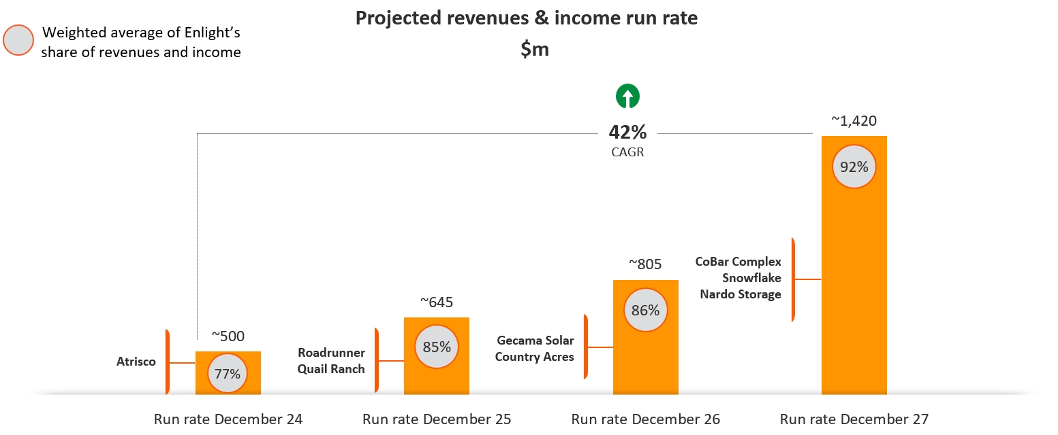

Financing Activities

 | • | During the quarter, the Company secured $1bn in financial closings for the Country Acres and Quail Ranch projects, representing 830 FMW of combined capacity.

 | • | Along with the financial close on the 560 FMW Roadrunner project in December 2024, the financing for the second wave of U.S. projects in now complete, with a total of $1.5bn raised.

 | • | Raising $245m through the sale of Series G and H bonds to finance the Company's growth.

 | • | Sale of 44% of the Sunlight cluster for $52m cash at a valuation of $119m, generating Adjusted EBITDA of $42m (actual consideration received less associated book value of assets) and a pre-tax profit of $97m.

 | • | As of the balance sheet date, the Company maintained $350m of revolving credit facilities, of which none have been drawn.

2025 Guidance

Construction and commissioning

 | • | Expected commissioning of 0.9 FGW of capacity, which is expected to add approximately $148-152m to annualized revenues and income and $129-133m annualized EBITDA, starting in 2026.

 | • | Starting construction on 2.9 FGW of capacity, which is expected to add approximately $487-495m in annualized revenues and income and approximately $428-436m in annualized EBITDA gradually through 2026-2027.

4 Projection based on 2025 guidance, adding on total revenues and income (sales of electricity and tax benefits) of under construction and pre-construction projects
5 The company's revenues from tax benefits are estimated at approximately 20-24% of the total revenue run rate for December 2025; approximately 22-26% of the total revenue run rate for December 2026, and approximately 26-30% of the total revenue run rate for December 2027

Financial guidance

 | • | Total revenues and income6 for 2025 are expected to range between $490m and $510m. Of the projected revenues and income, 38% are expected to be denominated in ILS, 35% in EUR, and 27% in USD.

 | • | Adjusted EBITDA7 for 2025 is expected to range between $360m and $380m.

 | • | Approximately 90% of the electricity volumes expected to be generated in 2025 will be sold at fixed prices through PPAs or hedges.

Financial Results Analysis

Revenues & Income by Segment
($ millions) | For the three months ended
Segment | 31/03/2025 | 31/03/2024 | % change
MENA | 42,867 | 28,474 | 51%
Europe | 51,384 | 59,160 | (13%)
U.S. | 34,789 | 4,495 | 674%
Other | 829 | 1,532 | (46%)
Total Revenues & Income | 129,869 | 93,661 | 39%

Revenues & Income

In the first quarter of 2025, the Company’s total revenues and income increased to $130m, up from $94m last year, a growth rate of 39% year over year. This was composed of revenues from the sale of electricity, which rose 21% to $110m compared to $90m in the same period of 2024, as well as recognition of $20m in income from tax benefits, up 516% compared to $3m in 1Q24.

The Company benefited from the revenues and income contribution of newly operational projects. Since the first quarter of last year, 576 MW and 1,526 MWh of new projects were connected to the grid and began selling electricity, including seven of the Israel Solar and Storage Cluster units in Israel, Atrisco in the U.S, Pupin in Serbia, and Tapolca in Hungary. The most important increases in revenue from the sale of electricity originated at Atrisco, which added $13m, followed by the Israel Solar and Storage Cluster, with $11m, while Pupin contributed $6m. In total, new projects contributed $30m to revenues from the sale of electricity.

Offsetting this growth, the amount of electricity generated at our wind projects operating in Europe was lower compared to the same period last year mainly due to weaker wind volumes. In addition, generation at project Bjornbeget in Sweden this quarter fell compared to last year due to a blade malfunction experienced at one of the site’s turbines. This prompted a complete shutdown of the wind farm, which is now in the process of gradually resuming operations. The Company recognized compensation of $4m from Bjornberget’s operating contractor in lieu of the lost revenues, which is recorded in other income.

Revenues and income were distributed between MENA, Europe, and the US, with 34% denominated in Israeli Shekel, 39% in Euros, and 27% denominated in US Dollars.

6 Total revenues and income include revenues from the sale of electricity along with income from tax benefits from US projects amounting to $60m-80m.
7 EBITDA is a non-IFRS financial measure. The Company is unable to provide a reconciliation of EBITDA to Net Income on a forward-looking basis without unreasonable effort because items that impact this IFRS financial measure are not within the Company’s control and/or cannot be reasonably predicted. Please refer to the reconciliation table in Appendix 2.

Net Income

In the first quarter of 2025, the Company’s net income amounted to $102m compared to $24m last year, an increase of 316% year over year. This increase stems from the $28m increase in revenues and income and $80m profit from the partial sale of the Sunlight cluster. This was offset by higher total operating expenses of $17m and net financial expenses of $10m (all after tax).

Adjusted EBITDA8

The Company’s Adjusted EBITDA grew by 84% to $132m in the first quarter of 2025, compared to $72m for the same period in 2024. Of this increase, $36m was driven by the factors described in the Revenues and Income section. The partial sale of the Sunlight cluster contributed $42m, representing the actual consideration received less the book value of the associated assets. Offsetting this growth was an increase of $11m in COGS linked to the addition of new projects, and an increase of $4m in operating expenses. Adjusting for the effects of this transaction, 1Q25 Adjusted EBITDA grew by 25% year-on-year to $90m.

8 Adjusted EBITDA is a non-IFRS measure. Please see the appendix of this presentation for a reconciliation to Net Income

Conference Call Information

Enlight plans to hold its First Quarter 2025 Conference Call and Webcasts on Tuesday, May 6, 2025 to review its financial results and business outlook in both English and Hebrew. Management will deliver prepared remarks followed by a question-and-answer session. Participants can join by dial-in or webcast:

• | English Conference Call at 8:00am ET / 3:00pm Israel:

Please pre-register to join by conference call using the following link:

https://register-conf.media-server.com/register/BI2f3b7998abd744a590906d1adabe0ad1

Upon registering, you will be emailed a dial-in number, direct passcode and unique PIN.

• | English Webcast at 8:00am ET / 3:00pm Israel:

Please register and join by webcast at the following link:
https://edge.media-server.com/mmc/p/z2k323sj

• | Hebrew Webcast at 5:00am ET / 12:00pm Israel:

Please join the webcast at the following link:
https://enlightenergy-co-il.zoom.us/webinar/register/WN_8lhirHEnQLyQju1pvoxZGg

The press release with the financial results as well as the investor presentation materials will be accessible from the Company’s website prior to the conference call. Approximately one hour after completion of the live call, an archived version of the webcast will be available on the Company’s investor relations website at https://enlightenergy.co.il/info/investors/.

Supplemental Financial and Other Information

We intend to announce material information to the public through the Enlight investor relations website at https://enlightenergy.co.il/info/investors, SEC filings, press releases, public conference calls, and public webcasts. We use these channels to communicate with our investors, customers, and the public about our company, our offerings, and other issues. As such, we encourage investors, the media, and others to follow the channels listed above, and to review the information disclosed through such channels. Any updates to the list of disclosure channels through which we will announce information will be posted on the investor relations page of our website.

Non-IFRS Financial Measures

This release presents Adjusted EBITDA, a financial metric, which is provided as a complement to the results provided in accordance with the International Financial Reporting Standards as issued by the International Accounting Standards Board (“IFRS”). A reconciliation of the non-IFRS financial information to the most directly comparable IFRS financial measure is provided in the accompanying tables found at the end of this release.

We define Adjusted EBITDA as net income (loss) plus depreciation and amortization, share based compensation, finance expenses, taxes on income and share in losses of equity accounted investees and minus finance income and non-recurring portions of other income, net. For the purposes of calculating Adjusted EBITDA, compensation for inadequate performance of goods and services procured by the Company are included in other income, net. Compensation for inadequate performance of goods and services reflects the profits the Company would have generated under regular operating conditions and is therefore included in Adjusted EBITDA. With respect to gains (losses) from asset disposals, as part of Enlight’s strategy to accelerate growth and reduce the need for equity financing, the Company sells parts of or the entirety of selected renewable project assets from time to time, and therefore includes realized gains or losses from these asset disposals in Adjusted EBITDA. In the case of partial assets disposals, Adjusted EBITDA includes only the actual consideration less the book value of the assets sold. Our management believes Adjusted EBITDA is indicative of operational performance and ongoing profitability and uses Adjusted EBITDA to evaluate the operating performance and for planning and forecasting purposes.

Non-IFRS financial measures have limitations as analytical tools and should not be considered in isolation or as substitutes for financial information presented under IFRS. There are a number of limitations related to the use of non-IFRS financial measures versus comparable financial measures determined under IFRS. For example, other companies in our industry may calculate the non-IFRS financial measures that we use differently or may use other measures to evaluate their performance. All of these limitations could reduce the usefulness of our non-IFRS financial measures as analytical tools. Investors are encouraged to review the related IFRS financial measure, Net Income, and the reconciliations of Adjusted EBITDA provided below to Net Income and to not rely on any single financial measure to evaluate our business.

Special Note Regarding Forward-Looking Statements

This press release contains forward-looking statements within the meaning of the U.S. Private Securities Litigation Reform Act of 1995. We intend such forward-looking statements to be covered by the safe harbor provisions for forward-looking statements as contained in Section 27A of the Securities Act of 1933, as amended, and Section 21E of the Securities Exchange Act of 1934, as amended. All statements contained in this press release other than statements of historical fact, including, without limitation, statements regarding the Company’s business strategy and plans, capabilities of the Company’s project portfolio and achievement of operational objectives, market opportunity, utility demand and potential growth, discussions with commercial counterparties and financing sources, pricing trends for materials, progress of Company projects, including anticipated timing of related approvals and project completion and anticipated production delays, the Company’s future financial results, expected impact from various regulatory developments and anticipated trade sanctions, expectations regarding wind production, electricity prices and windfall taxes, and Revenues and Income and Adjusted EBITDA guidance, the expected timing of completion of our ongoing projects, and the Company’s anticipated cash requirements and financing plans , are forward-looking statements. The words “may,” “might,” “will,” “could,” “would,” “should,” “expect,” “plan,” “anticipate,” “intend,” “target,” “seek,” “believe,” “estimate,” “predict,” “potential,” “continue,” “contemplate,” “possible,” “forecasts,” “aims” or the negative of these terms and similar expressions are intended to identify forward-looking statements, though not all forward-looking statements use these words or expressions.

These statements are neither promises nor guarantees, but involve known and unknown risks, uncertainties and other important factors that may cause our actual results, performance or achievements to be materially different from any future results, performance or achievements expressed or implied by the forward-looking statements, including, but not limited to, the following: our ability to site suitable land for, and otherwise source, renewable energy projects and to successfully develop and convert them into Operational Projects; availability of, and access to, interconnection facilities and transmission systems; our ability to obtain and maintain governmental and other regulatory approvals and permits, including environmental approvals and permits; construction delays, operational delays and supply chain disruptions leading to increased cost of materials required for the construction of our projects, as well as cost overruns and delays related to disputes with contractors; disruptions in trade caused by political, social or economic instability in regions where our components and materials are made; our suppliers’ ability and willingness to perform both existing and future obligations; competition from traditional and renewable energy companies in developing renewable energy projects; potential slowed demand for renewable energy projects and our ability to enter into new offtake contracts on acceptable terms and prices as current offtake contracts expire; offtakers’ ability to terminate contracts or seek other remedies resulting from failure of our projects to meet development, operational or performance benchmarks; exposure to market prices in some of our offtake contracts; various technical and operational challenges leading to unplanned outages, reduced output, interconnection or termination issues; the dependence of our production and revenue on suitable meteorological and environmental conditions, and our ability to accurately predict such conditions; our ability to enforce warranties provided by our counterparties in the event that our projects do not perform as expected; government curtailment, energy price caps and other government actions that restrict or reduce the profitability of renewable energy production; electricity price volatility, unusual weather conditions (including the effects of climate change, could adversely affect wind and solar conditions), catastrophic weather-related or other damage to facilities, unscheduled generation outages, maintenance or repairs, unanticipated changes to availability due to higher demand, shortages, transportation problems or other developments, environmental incidents, or electric transmission system constraints and the possibility that we may not have adequate insurance to cover losses as a result of such hazards; our dependence on certain operational projects for a substantial portion of our cash flows; our ability to continue to grow our portfolio of projects through successful acquisitions; changes and advances in technology that impair or eliminate the competitive advantage of our projects or upsets the expectations underlying investments in our technologies; our ability to effectively anticipate and manage cost inflation, interest rate risk, currency exchange fluctuations and other macroeconomic conditions that impact our business; our ability to retain and attract key personnel; our ability to manage legal and regulatory compliance and litigation risk across our global corporate structure; our ability to protect our business from, and manage the impact of, cyber-attacks, disruptions and security incidents, as well as acts of terrorism or war; changes to existing renewable energy industry policies and regulations that present technical, regulatory and economic barriers to renewable energy projects; the reduction, elimination or expiration of government incentives or benefits for, or regulations mandating the use of, renewable energy; our ability to effectively manage the global expansion of the scale of our business operations; our ability to perform to expectations in our new line of business involving the construction of PV systems for municipalities in Israel; our ability to effectively manage our supply chain and comply with applicable regulations with respect to international trade relations, the impact of tariffs on the cost of construction and our ability to mitigate such impact, sanctions, export controls and anti-bribery and anti-corruption laws; our ability to effectively comply with Environmental Health and Safety and other laws and regulations and receive and maintain all necessary licenses, permits and authorizations; our performance of various obligations under the terms of our indebtedness (and the indebtedness of our subsidiaries that we guarantee) and our ability to continue to secure project financing on attractive terms for our projects; limitations on our management rights and operational flexibility due to our use of tax equity arrangements; potential claims and disagreements with partners, investors and other counterparties that could reduce our right to cash flows generated by our projects; our ability to comply with increasingly complex tax laws of various jurisdictions in which we currently operate as well as the tax laws in jurisdictions in which we intend to operate in the future; the unknown effect of the dual listing of our ordinary shares on the price of our ordinary shares; various risks related to our incorporation and location in Israel, including the ongoing war in Israel, where our headquarters and some of our wind energy and solar energy projects are located; the costs and requirements of being a public company, including the diversion of management’s attention with respect to such requirements; certain provisions in our Articles of Association and certain applicable regulations that may delay or prevent a change of control; and other risk factors set forth in the section titled “Risk factors” in our Annual Report on Form 20-F for the fiscal year ended December 31, 2023, filed with the Securities and Exchange Commission (the “SEC”), as may be updated in our other documents filed with or furnished to the SEC.

These statements reflect management’s current expectations regarding future events and operating performance and speak only as of the date of this press release. You should not put undue reliance on any forward-looking statements. Although we believe that the expectations reflected in the forward-looking statements are reasonable, we cannot guarantee that future results, levels of activity, performance and events and circumstances reflected in the forward-looking statements will be achieved or will occur. Except as required by applicable law, we undertake no obligation to update or revise publicly any forward-looking statements, whether as a result of new information, future events or otherwise, after the date on which the statements are made or to reflect the occurrence of unanticipated events.

About Enlight

Founded in 2008, Enlight develops, finances, constructs, owns, and operates utility-scale renewable energy projects. Enlight operates across the three largest renewable segments today: solar, wind and energy storage. A global platform, Enlight operates in the United States, Israel and 10 European countries. Enlight has been traded on the Tel Aviv Stock Exchange since 2010 (TASE: ENLT) and completed its U.S. IPO (Nasdaq: ENLT) in 2023.

Company Contacts

Yonah Weisz
Director IR
investors@enlightenergy.co.il

Erica Mannion or Mike Funari
Sapphire Investor Relations, LLC
+1 617 542 6180
investors@enlightenergy.co.il

Appendix 1 – Financial information

Consolidated Statements of Income

 |  | For the three months ended at March 31
 |  | 2025 |  |  |  | 2024(*)
 |  | USD in |  |  |  | USD in
 |  | Thousands |  |  |  | Thousands
Revenues |  |  | 109,758 |  |  |  | 90,397
Tax benefits |  |  | 20,111 |  |  |  | 3,264
Total revenues and income |  |  | 129,869 |  |  |  | 93,661
Cost of sales (**) |  |  | (26,638 | ) |  |  | (15,436 | )
Depreciation and amortization |  |  | (33,789 | ) |  |  | (25,604 | )
General and administrative expenses |  |  | (11,846 | ) |  |  | (8,859 | )
Development expenses |  |  | (2,564 | ) |  |  | (2,418 | )
Total operating expenses |  |  | (74,837 | ) |  |  | (52,317 | )
Gains from projects disposals |  |  | 97,262 |  |  |  | 27
Other income (expenses), net |  |  | (1,105 | ) |  |  | 1,517
Operating profit |  |  | 151,189 |  |  |  | 42,888
Finance income |  |  | 6,695 |  |  |  | 8,065
Finance expenses |  |  | (30,203 | ) |  |  | (19,493 | )
Total finance expenses, net |  |  | (23,508 | ) |  |  | (11,428 | )
Profit before tax and equity loss |  |  | 127,681 |  |  |  | 31,460
Share of losses of equity accounted investees |  |  | (1,227 | ) |  |  | (144 | )
Profit before income taxes |  |  | 126,454 |  |  |  | 31,316
Taxes on income |  |  | (24,651 | ) |  |  | (6,831 | )
Profit for the period |  |  | 101,803 |  |  |  | 24,485
Profit for the period attributed to:
Owners of the Company |  |  | 94,458 |  |  |  | 16,763
Non-controlling interests |  |  | 7,345 |  |  |  | 7,722
 |  |  | 101,803 |  |  |  | 24,485
Earnings per ordinary share (in USD) with a par value of
NIS 0.1, attributable to owners of the parent Company:
Basic earnings per share |  |  | 0.80 |  |  |  | 0.14
Diluted earnings per share |  |  | 0.75 |  |  |  | 0.14
Weighted average of share capital used in the
calculation of earnings:
Basic per share |  |  | 118,783,541 |  |  |  | 117,963,310
Diluted per share |  |  | 125,316,177 |  |  |  | 122,889,909

(*) The Consolidated Statements of Income have been adjusted to present comparable information for the previous period. For additional details please see Appendix 8.
(**) Excluding depreciation and amortization.

Consolidated Statements of Financial Position as of

 |  | March 31 |  |  |  | December 31
 |  | 2025 |  |  |  | 2024
 |  | USD in |  |  |  | USD in
 |  | Thousands |  |  |  | Thousands
Assets
Current assets
Cash and cash equivalents |  |  | 449,530 |  |  |  | 387,427
Restricted cash |  |  | 82,692 |  |  |  | 87,539
Trade receivables |  |  | 73,125 |  |  |  | 50,692
Other receivables |  |  | 71,475 |  |  |  | 99,651
Other financial assets |  |  | 405 |  |  |  | 975
Assets of disposal groups classified as held for sale |  |  | - |  |  |  | 81,661
Total current assets |  |  | 677,227 |  |  |  | 707,945
Non-current assets
Restricted cash |  |  | 59,964 |  |  |  | 60,802
Other long-term receivables |  |  | 62,092 |  |  |  | 61,045
Deferred costs in respect of projects |  |  | 392,119 |  |  |  | 357,358
Deferred borrowing costs |  |  | 61 |  |  |  | 276
Loans to investee entities |  |  | 32,329 |  |  |  | 18,112
Investments in equity accounted investees |  |  | 49,303 |  |  |  | -
Fixed assets, net |  |  | 3,961,021 |  |  |  | 3,699,192
Intangible assets, net |  |  | 293,035 |  |  |  | 291,442
Deferred taxes assets |  |  | 8,023 |  |  |  | 10,744
Right-of-use asset, net |  |  | 210,739 |  |  |  | 210,941
Financial assets at fair value through profit or loss |  |  | 74,555 |  |  |  | 69,216
Other financial assets |  |  | 63,903 |  |  |  | 59,812
Total non-current assets |  |  | 5,207,144 |  |  |  | 4,838,940
Total assets |  |  | 5,884,371 |  |  |  | 5,546,885

Consolidated Statements of Financial Position as of (Cont.)

 |  | March 31 |  |  |  | December 31
 |  | 2025 |  |  |  | 2024
 |  | USD in |  |  |  | USD in
 |  | Thousands |  |  |  | Thousands
Liabilities and equity
Current liabilities
Credit and current maturities of loans from  banks and other financial institutions |  |  | 207,662 |  |  |  | 212,246
Trade payables |  |  | 167,765 |  |  |  | 161,991
Other payables |  |  | 101,928 |  |  |  | 107,825
Current maturities of debentures |  |  | 23,049 |  |  |  | 44,962
Current maturities of lease liability |  |  | 10,192 |  |  |  | 10,240
Other financial liabilities |  |  | 5,777 |  |  |  | 8,141
Liabilities of disposal groups classified as held for sale |  |  | - |  |  |  | 46,635
Total current liabilities |  |  | 516,373 |  |  |  | 592,040
Non-current liabilities
Debentures |  |  | 549,517 |  |  |  | 433,994
Other financial liabilities |  |  | 118,891 |  |  |  | 107,865
Convertible debentures |  |  | 232,536 |  |  |  | 133,056
Loans from banks and other financial institutions |  |  | 2,024,315 |  |  |  | 1,996,137
Loans from non-controlling interests |  |  | 79,081 |  |  |  | 75,598
Financial liabilities through profit or loss |  |  | 25,985 |  |  |  | 25,844
Deferred taxes liabilities |  |  | 62,310 |  |  |  | 41,792
Employee benefits |  |  | 1,092 |  |  |  | 1,215
Lease liability |  |  | 209,958 |  |  |  | 211,941
Deferred income related to tax equity |  |  | 387,943 |  |  |  | 403,384
Asset retirement obligation |  |  | 85,141 |  |  |  | 83,085
Total non-current liabilities |  |  | 3,776,769 |  |  |  | 3,513,911
Total liabilities |  |  | 4,293,142 |  |  |  | 4,105,951
Equity
Ordinary share capital |  |  | 3,323 |  |  |  | 3,308
Share premium |  |  | 1,028,528 |  |  |  | 1,028,532
Capital reserves |  |  | 49,890 |  |  |  | 25,273
Proceeds on account of convertible options |  |  | 25,083 |  |  |  | 15,494
Accumulated profit |  |  | 202,377 |  |  |  | 107,919
Equity attributable to shareholders of the Company |  |  | 1,309,201 |  |  |  | 1,180,526
Non-controlling interests |  |  | 282,028 |  |  |  | 260,408
Total equity |  |  | 1,591,229 |  |  |  | 1,440,934
Total liabilities and equity |  |  | 5,884,371 |  |  |  | 5,546,885

Consolidated Statements of Cash Flows

For the three months ended
at March 31
 |  | 2025 |  |  |  | 2024
 |  | USD in |  |  |  | USD in
 |  | Thousands |  |  |  | Thousands
Cash flows for operating activities
Profit for the period |  |  | 101,803 |  |  |  | 24,485
Income and expenses not associated with cash flows:
Depreciation and amortization |  |  | 33,789 |  |  |  | 25,604
Finance expenses, net |  |  | 22,388 |  |  |  | 11,486
Share-based compensation |  |  | 1,710 |  |  |  | 3,117
Taxes on income |  |  | 24,651 |  |  |  | 6,831
Tax benefits |  |  | (20,111 | ) |  |  | (3,264 | )
Other income (expenses), net |  |  | 1,105 |  |  |  | (134 | )
Company’s share in losses of investee partnerships |  |  | 1,227 |  |  |  | 144
Gains from projects disposals |  |  | (97,262 | ) |  |  | (27 | )
 |  |  | (32,503 | ) |  |  | 43,757
Changes in assets and liabilities items:
Change in other receivables |  |  | (856 | ) |  |  | (2,142 | )
Change in trade receivables |  |  | (20,376 | ) |  |  | (16,909 | )
Change in other payables |  |  | 8,604 |  |  |  | (539 | )
Change in trade payables |  |  | 7,802 |  |  |  | 71
 |  |  | (4,826 | ) |  |  | (19,519 | )
Interest receipts |  |  | 2,512 |  |  |  | 2,928
Interest paid |  |  | (22,298 | ) |  |  | (15,624 | )
Income Tax paid |  |  | (1,075 | ) |  |  | (798 | )
Net cash from operating activities |  |  | 43,613 |  |  |  | 35,229
Cash flows for investing activities
Sale (Acquisition) of consolidated entities, net |  |  | 36,223 |  |  |  | (1,388 | )
Changes in restricted cash and bank deposits, net |  |  | 8,176 |  |  |  | (4,988 | )
Purchase, development, and construction in respect of projects |  |  | (255,862 | ) |  |  | (199,733 | )
Loans provided and Investment in investees |  |  | (7,430 | ) |  |  | (11,284 | )
Repayments of loans from investees |  |  | 30,815 |  |  |  | -
Payments on account of acquisition of consolidated entity |  |  | (7,447 | ) |  |  | (10,851 | )
Purchase of financial assets measured at fair value through profit or loss, net |  |  | (3,040 | ) |  |  | (8,409 | )
Net cash used in investing activities |  |  | (198,565 | ) |  |  | (236,653 | )

Consolidated Statements of Cash Flows (Cont.)

 |  | For the three months ended at March 31
 |  | 2025 |  |  |  | 2024
 |  | USD in |  |  |  | USD in
 |  | Thousands |  |  |  | Thousands
Cash flows from financing activities
Receipt of loans from banks and other financial institutions |  |  | 143,578 |  |  |  | 71,371
Repayment of loans from banks and other financial institutions |  |  | (108,922 | ) |  |  | (10,448 | )
Issuance of debentures |  |  | 125,838 |  |  |  | -
Issuance of convertible debentures |  |  | 114,685 |  |  |  | -
Repayment of debentures |  |  | (21,994 | ) |  |  | (1,284 | )
Dividends and distributions by subsidiaries to non-controlling interests |  |  | - |  |  |  | (108 | )
Deferred borrowing costs |  |  | (35,199 | ) |  |  | (2,682 | )
Repayment of loans from non-controlling interests |  |  | - |  |  |  | (955 | )
Increase in holding rights of consolidated entity |  |  | (1,392 | ) |  |  | -
Exercise of share options |  |  | 11 |  |  |  | -
Repayment of lease liability |  |  | (4,058 | ) |  |  | (3,671 | )
Proceeds from investment in entities by non-controlling interest |  |  | 7,732 |  |  |  | 152
Net cash from financing activities |  |  | 220,279 |  |  |  | 52,375
Increase (Decrease) in cash and cash equivalents |  |  | 65,327 |  |  |  | (149,049 | )
Balance of cash and cash equivalents at beginning of period |  |  | 387,427 |  |  |  | 403,805
Effect of exchange rate fluctuations on cash and cash equivalents |  |  | (3,224 | ) |  |  | (4,905 | )
Cash and cash equivalents at end of period |  |  | 449,530 |  |  |  | 249,851

Information related to Segmental Reporting

 |  | For the three months ended at March 31, 2025
 |  | MENA(**) |  |  |  | Europe(**) |  |  |  | USA |  |  |  | Total reportable segments |  |  |  | Others |  |  |  | Total
 |  | USD in thousands
Revenues |  |  | 42,867 |  |  |  | 51,384 |  |  |  | 14,678 |  |  |  | 108,929 |  |  |  | 829 |  |  |  | 109,758
Tax benefits |  |  | - |  |  |  | - |  |  |  | 20,111 |  |  |  | 20,111 |  |  |  | - |  |  |  | 20,111
Total revenues and income |  |  | 42,867 |  |  |  | 51,384 |  |  |  | 34,789 |  |  |  | 129,040 |  |  |  | 829 |  |  |  | 129,869
Segment adjusted EBITDA |  |  | 68,017 |  |  |  | 44,663 |  |  |  | 30,549 |  |  |  | 143,229 |  |  |  | 81 |  |  |  | 143,310
Reconciliations of unallocated amounts:
Headquarter costs (*) |  |  |  |  |  |  |  |  |  |  |  |  |  |  |  |  |  |  |  |  |  |  | (11,701 | )
Intersegment profit |  |  |  |  |  |  |  |  |  |  |  |  |  |  |  |  |  |  |  |  |  |  | 106
Gains from projects disposals |  |  |  |  |  |  |  |  |  |  |  |  |  |  |  |  |  |  |  |  |  |  | 54,973
Depreciation and amortization and share-based compensation |  |  |  |  |  |  |  |  |  |  |  |  |  |  |  |  |  |  |  |  |  |  | (35,499 | )
Operating profit |  |  |  |  |  |  |  |  |  |  |  |  |  |  |  |  |  |  |  |  |  |  | 151,189
Finance income |  |  |  |  |  |  |  |  |  |  |  |  |  |  |  |  |  |  |  |  |  |  | 6,695
Finance expenses |  |  |  |  |  |  |  |  |  |  |  |  |  |  |  |  |  |  |  |  |  |  | (30,203 | )
Share in the losses of equity accounted investees |  |  |  |  |  |  |  |  |  |  |  |  |  |  |  |  |  |  |  |  |  |  | (1,227 | )
Profit before income taxes |  |  |  |  |  |  |  |  |  |  |  |  |  |  |  |  |  |  |  |  |  |  | 126,454

(*) | Including general and administrative and development expenses (excluding depreciation and amortization and share based compensation).

(**) | Due to the Company's organizational restructuring, the Chief Operation Decision Maker (CODM) now reviews the group’s results by segmenting them into three business units: MENA (Middle East and North Africa), Europe, and the US. Consequently, the Central/Eastern Europe and Western Europe segments have been consolidated into the "Europe" segment, the Israel segment has been incorporated into the MENA segment, and the Management and Construction segment has been excluded. The comparative figures for the three months ended March 31, 2024, have been updated accordingly.

Information related to Segmental Reporting

 |  | For the three months ended at March 31, 2024
 |  | MENA |  |  |  | Europe |  |  |  | USA |  |  |  | Total reportable segments |  |  |  | Others |  |  |  | Total
 |  | USD in thousands
Revenues |  |  | 28,474 |  |  |  | 59,160 |  |  |  | 1,231 |  |  |  | 88,865 |  |  |  | 1,532 |  |  |  | 90,397
Tax benefits |  |  | - |  |  |  | - |  |  |  | 3,264 |  |  |  | 3,264 |  |  |  | - |  |  |  | 3,264
Total revenues and income |  |  | 28,474 |  |  |  | 59,160 |  |  |  | 4,495 |  |  |  | 92,129 |  |  |  | 1,532 |  |  |  | 93,661
Segment adjusted EBITDA |  |  | 24,528 |  |  |  | 50,707 |  |  |  | 3,122 |  |  |  | 78,357 |  |  |  | 668 |  |  |  | 79,025

Reconciliations of unallocated amounts:
Headquarter costs (*) |  |  | (7,606 | )
Intersegment profit |  |  | 190
Depreciation and amortization and share-based compensation |  |  | (28,721 | )
Operating profit |  |  | 42,888
Finance income |  |  | 8,065
Finance expenses |  |  | (19,493 | )
Share in the losses of equity accounted investees |  |  | (144 | )
Profit before income taxes |  |  | 31,316

(*) | Including general and administrative and development expenses (excluding depreciation and amortization and share based compensation).

Appendix 2 - econciliations between Net Income to Adjusted EBITDA

($ thousands) |  | For the three months ended at
 |  | March 31, 2025 |  | March 31, 2024
Net Income |  | 101,803 |  | 24,485
Depreciation and amortization |  | 33,789 |  | 25,604
Share based compensation |  | 1,710 |  | 3,117
Finance income |  | (6,695) |  | (8,065)
Finance expenses |  | 30,203 |  | 19,493
Gains from projects disposals (*) |  | (54,973) |  | -
Share of losses of equity accounted investees |  | 1,227 |  | 144
Taxes on income |  | 24,651 |  | 6,831
Adjusted EBITDA |  | 131,715 |  | 71,609

* Profit from revaluation linked to partial sale of asset.

Appendix 3 – Debentures Covenants

Debentures Covenants

As of March 31, 2025, the Company was in compliance with all of its financial covenants under the indenture for the Series C, D, F, G and H Debentures, based on having achieved the following in its consolidated financial results:

Minimum equity

The company's equity shall be maintained at no less than NIS 375 million so long as debentures F remain outstanding, NIS 1,250 million so long as debentures C and D remain outstanding, and USD 600 million so long as debentures G and H remain outstanding.

As of March 31, 2025, the company’s equity amounted to NIS 5,916 million (USD 1,591 million).

Net financial debt to net CAP

The ratio of standalone net financial debt to net CAP shall not exceed 70% for two consecutive financial periods so long as debentures F remain outstanding and shall not exceed 65% for two consecutive financial periods so long as debentures C, D, G and H remain outstanding.

As of March 31, 2025, the net financial debt to net CAP ratio, as defined above, stands at 36%.

Net financial debt to EBITDA

So long as debentures F remain outstanding, standalone financial debt shall not exceed NIS 10 million, and the consolidated financial debt to EBITDA ratio shall not exceed 18 for more than two consecutive financial periods.

For as long as debentures C and D remain outstanding, the consolidated financial debt to EBITDA ratio shall not exceed 15 for more than two consecutive financial periods.

For as long as debentures G and H remain outstanding, the consolidated financial debt to EBITDA ratio shall not exceed 17 for more than two consecutive financial periods.

As of March 31, 2025, the net financial debt to EBITDA ratio, as defined above, stands at 8.

Equity to balance sheet

The standalone equity to total balance sheet ratio shall be maintained at no less than 20% ,25% and 28%, respectively, for two consecutive financial periods for as long as debentures F, debentures C and D and debentures G and H remain outstanding.

As of March 31, 2025, the equity to balance sheet ratio, as defined above, stands at 55%.

Appendix 4 a) Segment information: Operational projects

($ thousands) |  |  | 3 Months ended March 31
Operational Project Segments | Installed Capacity (MW) | Installed Storage (MWh) | Generation  (GWh) |  | Revenues and  income |  | Segment Adjusted  EBITDA*
Operational Project Segments | Installed Capacity (MW) | Installed Storage (MWh) | 2025 | 2024 | 2025 | 2024 | 2025 | 2024
MENA | 652 | 625 | 317 | 251 | 42,867 | 28,474 | 25,750 | 24,528
Europe | 1,327 | - | 704 | 823 | 51,384 | 59,160 | 44,663 | 50,707
USA | 470 | 1,200 | 209 | 26 | 34,789 | 4,494 | 30,549 | 3,121
Total Consolidated | 2,449 | 1,825 | 1,230 | 1,100 | 129,040 | 92,128 | 100,962 | 78,356
Unconsolidated at share | 42 | 41
Total | 2,491 | 1,866

b) | Operational Projects Further Detail

($ thousands) |  |  |  | 3 Months ended March 31, 2025
Operational Project | Segment | Installed  Capacity (MW) | Installed  Storage  (MWh) | Reported Revenue | Segment  Adjusted  EBITDA* | Debt balance as of  March 31, 2025 | Ownership %**
MENA Wind | MENA | 316 | - | 22,301 |  | 448,750 | 49%
MENA PV | MENA | 336 | 625 | 20,566 |  | 486,006 | 76%
Total MENA |  | 652 | 625 | 42,867 | 25,750 | 934,756
Europe Wind | Europe | 1,184 | - | 48,794 |  | 723,145 | 66%
Europe PV | Europe | 143 | - | 2,590 |  | 68,066 | 76%
Total Europe |  | 1,327 | - | 51,384 | 44,663 | 791,211
USA PV | USA | 470 | 1,200 | 34,789 |  | 288,790 | 100%
Total USA |  | 470 | 1,200 | 34,789 | 30,549 | 288,790
Total Consolidated Projects |  | 2,449 | 1,825 | 129,040 | 100,962 | 2,014,757
Uncons. Projects at share |  | 42 | 41 |  |  |  | 50%
Total |  | 2,491 | 1,866 | 129,040 | 100,962 | 2,014,757

* EBITDA results included $4m in the 3-month ended March 25, of compensation recognized from Björnberget project

** Ownership % is calculated based on the project's share of total revenues

c) | Projects under construction

($ millions)  Consolidated Projects | Country | Generation and energy storage Capacity (MW/MWh( | Est.  COD | Est. Total  Project Cost** | Tax credit benefit- Qualifying category | Tax credit benefit- Adders***** | Discounted Value of Tax Benefit*** | Est. Total  Project Cost net of tax benefit | Capital Invested as of March 31, 2025 | Est. Equity Required (%) | Equity Invested as of March 31, 2025 | Est. First Full Year Revenue** | Est. First Full Year EBITDA**&**** | Ownership %*
Country Acres | USA | 403/688 | H2 2026 | 826-864 | ITC | DC (10%) | 390-405 | 436-459 | 136 | 10%-11% | 91 | 61-62 | 45-46 | 100%
Quail Ranch BESS | USA | 0/400 | H2 2025 | 123-150 | ITC | EC (10%) | 60-72 | 63-78 | 85 | 12%-15% | 85 | 22-23 | 17-19 | 100%
Quail Ranch Solar | USA | 128/0 | H2 2025 | 141-148 | PTC | EC (10%) | 69-73 | 72-75 |  |  |  |  |  | 100%
Roadrunner BESS | USA | 0/940 | H2 2025 | 318-341 | ITC | EC (10%) | 145-155 | 173-186 | 151 | 0%-10%******** | 61 | 52-55 | 41-43 | 100%
Roadrunner Solar | USA | 290/0 | H2 2025 | 284-299 | PTC | EC (10%) | 167-175 | 117-124 |  |  |  |  |  | 100%
Gecama Solar | Spain | 225/220 | H1 2026 | 195-205 | - | - | - | 195-205 | 18 | 23%-28% | 18 | 38-40 | 31-33 | 72%
Bjornberget – BESS | Sweden | 0/96 | 2026 | 25-27 | - | - | - | 25-27 | 0 | 90%-100% | 0 | 9-10 | 8 | 55%
Israel Construction | Israel | 26/241 | H1 2025-H1 2026 | 67-69 | - | - | - | 67-69 | 37 | 20%-30% | 37 | 10-11 | 7-8 | 95%
Total Consolidated Projects |  | 1,072/  2,585 |  | 1,979-2,103 |  |  | 831-880 | 1,148-1,223 | 427 |  | 292 | 192-201 | 149-157
Unconsolidated Projects at share****** | Israel | 4/79 | H2 2025- H2 2026 | 19-20 | - | - | - | - | 6 | 15%-25% | 6 | 3-4 | 2 | 65%
Total |  | 1,076/  2,664 |  | 1,998-2,123 |  |  | 831-880 | 1,148-1,223 | 433 |  | 298 | 195-205 | 151-158

d) Pre-Construction Projects (due to commence construction within 12 months of the Approval Date)

($ millions)  Consolidated Projects | Country | Generation and energy storage Capacity (MW/MWh) | Est.  COD | Est. Total  Project Cost** | Tax Credit Benefit |  |  | Est. Total  Project Cost net of tax benefit | Capital Invested as of March 31, 2025 | Est. Equity Required (%) | Equity Invested as of March 31, 2025 | Est. First Full Year Revenue** | Est. First Full Year EBITDA**&**** | Ownership %*
 |  |  |  |  | Qualifying Category | Adders***** | Discounted Value of Tax Benefit***
CoBar ITC | United States | 258/824 | H2 2027 | 606-660 | ITC | EC (10%) | 267-290 | 339-370 | 40 | 12%-15% | 40 | 125-128 | 96-101 | 100%
CoBar PTC | United States | 953/0 | H2 2027 | 1,090-1,124 | PTC | EC (10%) | 558-565 | 532-559
Snowflake A | United States | 600/1,900 | 2027 | 1,475-1,615 | ITC | EC (10%) | 575-636 | 900-979 | 10 | 10% | 10 | 122-128 | 97-103 | 100%
Nardo Storage | Italy | 0/920 | H2 2027 | 146-154 | - | - | - | 146-154 | 3 | 18%-22% | 3 | 32-34 | 27-29 | 100%

($ millions)  Additional Pre-Construction Projects | MW Deployment  MW/MWh |  |  | Est. Total  Project Cost** | Tax Credit Benefit |  | Discounted Value of Tax Benefit*** | Est. Total  Project Cost net of tax benefit | Capital Invested as of March 31, 2025 | Est. Equity Required (%) | Equity Invested as of March 31, 2025 | Est. First Full Year Revenue** | Est. First Full Year EBITDA**&**** | Ownership %*
($ millions)  Additional Pre-Construction Projects | 2026 | 2027 | 2028 | Est. Total  Project Cost** | Qualifying Category | Adders*****
United States******* | - | 432/400 | 256/0 | 1,213-1,241 | ITC | DC (10%) & EC (10%) | 498-511 | 715-730 | 44 | 10%-20% | 44 | 90-92 | 70-71 | 100%
Europe | - | 0/100 | - | 30-31 | - | - | - | 30-31 | 0 | 25%-35% | 0 | 12 | 8 | 100%
MENA | 0/20 | 38/31 | - | 88-91 | - | - | - | 88-91 | 10 | 25%-35% | 10 | 8 | 7 | 84%
Total Consolidated Projects | 0/20 | 470/531 | 256/0 | 1,331-1,363 |  |  | 498-511 | 833-852 | 54 |  | 54 | 110-112 | 85-86
Unconsolidated Projects at share | 8/42 | 0/79 | - | 45-46 | - | - | - | 45-46 | 0 | 25% | 0 | 4 | 3 | 53%
Total Pre-Construction | 2,545MW +4,316MWh |  |  | 4,693-4,962 |  |  | 1,898-2,002 | 2,795-2,960 | 107 |  | 107 | 393-406 | 308-322

* The legal ownership share for all U.S. projects is 90%, but Enlight invests 100% of the equity in the project and entitled to 100% of the project distributions until full repayment of Enlight's capital plus a preferred return

** Estimates of the impact of U.S. tariffs on construction costs for U.S. projects currently under construction are based on the following assumptions: tariffs on Chinese imports ranging 0-70% , and 10% on imports from all other countries; the willingness of suppliers to take on a portion of the increase in costs, based in part on current negotiations with them; an increase in the expected revenues and EBITDA of selected projects, based on current negotiations with relevant utilities. These estimates and assumptions involve risks and uncertainties and reflect management’s current expectations based on available information. We cannot guarantee that actual results achieved will reflect these estimates and assumptions.

***Tax benefits under the IRA. PTC is assumed, based on the project’s expected production and a yearly CPI indexation of 2%, discounted by 8% to COD. For the ITC, a step-up adjustment was made to reflect the eligible higher tax credit rates, enhancing the valuation and return of the project by considering the increased project value.**** EBITDA is a non-IFRS financial measure. This figure represents consolidated EBITDA for the project and excludes the share of project distributions to tax equity partners, as well as ITC and PTC proceeds. These components of the tax equity transaction may differ from project to project, are subject to market conditions and commercial terms agreed upon reaching financial close.*****The Energy Community (EC) Adder provides extra credits for renewable energy projects in areas impacted by fossil fuel reliance or economic transition. The Domestic Content (DC) Adder rewards projects using U.S.-manufactured components, promoting local job creation and supply chain growth

****** All numbers, beside equity invested, reflects Enlight share only *******Including Rustic hills 1+2, Coggon, Gemstone and Crimson orchard******** The required equity during construction is estimated at 10% and is expected to decrease to 0% at COD

Appendix 5 – cash and cash equivalents

($ thousands) | March 31, 2025
Cash and Cash Equivalents:
Enlight Renewable Energy Ltd, Enlight EU Energies Kft and Enlight Renewable LLC excluding subsidiaries (“Topco”) | 181,232
Subsidiaries | 268,298
Deposits:
Short term deposits | -
Restricted Cash:
Projects under construction | 82,692
Reserves, including debt service, performance obligations and others | 59,964
Total Cash | 592,186

Appendix 6 – Corporate level (TopCo) debt

($ thousands) | March 31, 2025
Debentures:
Debentures | 572,566*
Convertible debentures | 232,536
Loans from banks and other financial institutions:
Credit and short-term loans from banks and other financial institutions | -
Loans from banks and other financial institutions | 116,364
Total corporate level debt | 921,466

* Including current maturities of debentures in the amount of 23,049

Appendix 7 – Functional Currency Conversion Rates:

The financial statements of each of the Company’s subsidiaries were prepared in the currency of the main economic environment in which it operates (hereinafter: the “Functional Currency”). For the purpose of consolidating the financial statements, results and financial position of each of the Group’s member companies are translated into the Israeli shekel (“NIS”), which is the Company’s Functional Currency. The Group’s consolidated financial statements are presented in U.S. dollars (“USD”).

FX Rates to USD:

Date of the financial statements: | Euro | NIS
As of 31th March 2025 | 1.08 | 0.27
As of 31th March 2024 | 1.08 | 0.27

Average for the 3 months period ended:
March 2025 | 1.05 | 0.28
March 2024 | 1.09 | 0.28

Appendix 8 – Structural changes to the Consolidated Statements of Income:

The Company has changed its presentation of its Income Statement, which includes the presentation of specified items that have been previously included within other income (i.e. tax equity). In addition, the Company has decided to remove the Gross Profit line item.

The Company believes that such presentation provides a more relevant information and better reflects the measurement of its financial performance. The Company applied such change retrospectively.

Exhibit 99.2

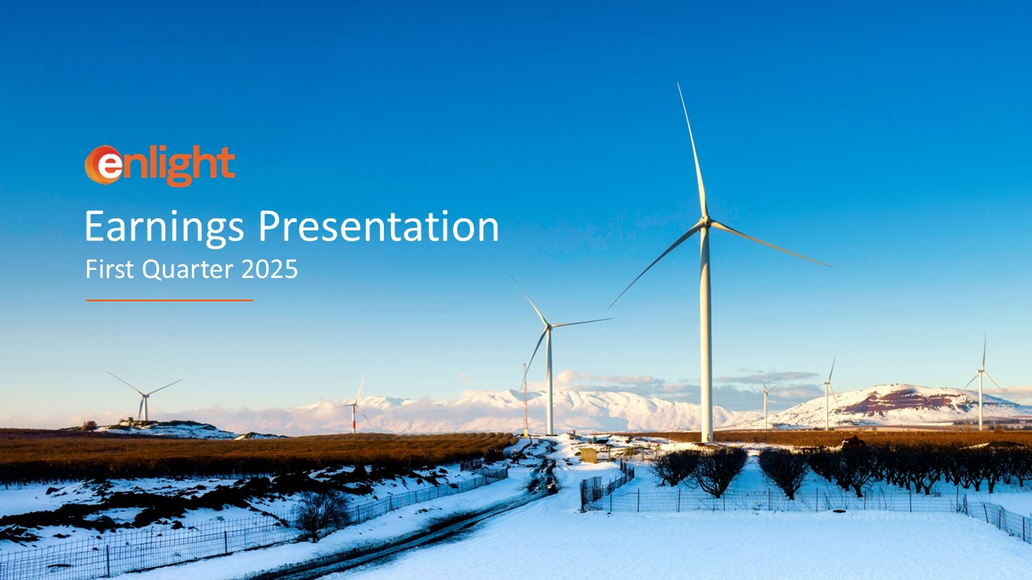
First Quarter 2025 Earnings Presentation

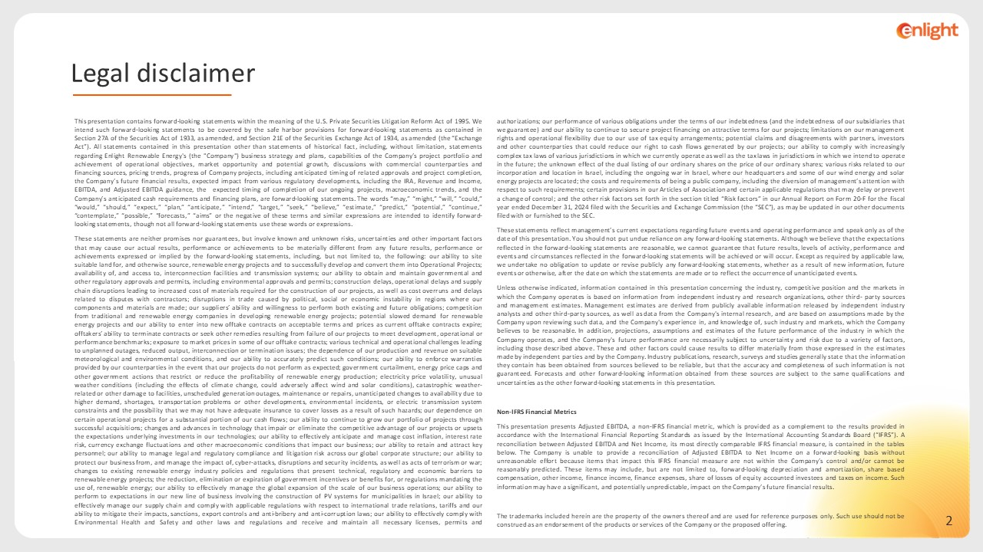
This presentation contains forward-looking statements within the meaning of the U.S. Private Securities Litigation Reform Act of 1995. We intend such forward-looking statements to be covered by the safe harbor provisions for forward-looking statements as contained in Section 27A of the Securities Act of 1933, as amended, and Section 21E of the Securities Exchange Act of 1934, as amended (the “Exchange Act”). All statements contained in this presentation other than statements of historical fact, including, without limitation, statements regarding Enlight Renewable Energy's (the "Company") business strategy and plans, capabilities of the Company’s project portfolio and achievement of operational objectives, market opportunity and potential growth, discussions with commercial counterparties and financing sources, pricing trends, progress of Company projects, including anticipated timing of related approvals and project completion, the Company’s future financial results, expected impact from various regulatory developments, including the IRA, Revenue and Income, EBITDA, and Adjusted EBITDA guidance, the expected timing of completion of our ongoing projects, macroeconomic trends, and the Company’s anticipated cash requirements and financing plans, are forward-looking statements. The words “may,” “might,” “will,” “could,” “would,” “should,” “expect,” “plan,” “anticipate,” “intend,” “target,” “seek,” “believe,” “estimate,” “predict,” “potential,” “continue,” “contemplate,” “possible,” “forecasts,” “aims” or the negative of these terms and similar expressions are intended to identify forward-looking statements, though not all forward-looking statements use these words or expressions. These statements are neither promises nor guarantees, but involve known and unknown risks, uncertainties and other important factors that may cause our actual results, performance or achievements to be materially different from any future results, performance or achievements expressed or implied by the forward-looking statements, including, but not limited to, the following: our ability to site suitable land for, and otherwise source, renewable energy projects and to successfully develop and convert them into Operational Projects; availability of, and access to, interconnection facilities and transmission systems; our ability to obtain and maintain governmental and other regulatory approvals and permits, including environmental approvals and permits; construction delays, operational delays and supply chain disruptions leading to increased cost of materials required for the construction of our projects, as well as cost overruns and delays related to disputes with contractors; disruptions in trade caused by political, social or economic instability in regions where our components and materials are made; our suppliers’ ability and willingness to perform both existing and future obligations; competition from traditional and renewable energy companies in developing renewable energy projects; potential slowed demand for renewable energy projects and our ability to enter into new offtake contracts on acceptable terms and prices as current offtake contracts expire; offtakers’ ability to terminate contracts or seek other remedies resulting from failure of our projects to meet development, operational or performance benchmarks; exposure to market prices in some of our offtake contracts; various technical and operational challenges leading to unplanned outages, reduced output, interconnection or termination issues; the dependence of our production and revenue on suitable meteorological and environmental conditions, and our ability to accurately predict such conditions; our ability to enforce warranties provided by our counterparties in the event that our projects do not perform as expected; government curtailment, energy price caps and other government actions that restrict or reduce the profitability of renewable energy production; electricity price volatility, unusual weather conditions (including the effects of climate change, could adversely affect wind and solar conditions), catastrophic weather-related or other damage to facilities, unscheduled generation outages, maintenance or repairs, unanticipated changes to availability due to higher demand, shortages, transportation problems or other developments, environmental incidents, or electric transmission system constraints and the possibility that we may not have adequate insurance to cover losses as a result of such hazards; our dependence on certain operational projects for a substantial portion of our cash flows; our ability to continue to grow our portfolio of projects through successful acquisitions; changes and advances in technology that impair or eliminate the competitive advantage of our projects or upsets the expectations underlying investments in our technologies; our ability to effectively anticipate and manage cost inflation, interest rate risk, currency exchange fluctuations and other macroeconomic conditions that impact our business; our ability to retain and attract key personnel; our ability to manage legal and regulatory compliance and litigation risk across our global corporate structure; our ability to protect our business from, and manage the impact of, cyber-attacks, disruptions and security incidents, as well as acts of terrorism or war; changes to existing renewable energy industry policies and regulations that present technical, regulatory and economic barriers to renewable energy projects; the reduction, elimination or expiration of government incentives or benefits for, or regulations mandating the use of, renewable energy; our ability to effectively manage the global expansion of the scale of our business operations; our ability to perform to expectations in our new line of business involving the construction of PV systems for municipalities in Israel; our ability to effectively manage our supply chain and comply with applicable regulations with respect to international trade relations, tariffs and our ability to mitigate their impacts, sanctions, export controls and anti-bribery and anti-corruption laws; our ability to effectively comply with Environmental Health and Safety and other laws and regulations and receive and maintain all necessary licenses, permits and authorizations; our performance of various obligations under the terms of our indebtedness (and the indebtedness of our subsidiaries that we guarantee) and our ability to continue to secure project financing on attractive terms for our projects; limitations on our management rights and operational flexibility due to our use of tax equity arrangements; potential claims and disagreements with partners, investors and other counterparties that could reduce our right to cash flows generated by our projects; our ability to comply with increasingly complex tax laws of various jurisdictions in which we currently operate as well as the tax laws in jurisdictions in which we intend to operate in the future; the unknown effect of the dual listing of our ordinary shares on the price of our ordinary shares; various risks related to our incorporation and location in Israel, including the ongoing war in Israel, where our headquarters and some of our wind energy and solar energy projects are located; the costs and requirements of being a public company, including the diversion of management’s attention with respect to such requirements; certain provisions in our Articles of Association and certain applicable regulations that may delay or prevent a change of control; and the other risk factors set forth in the section titled “Risk factors” in our Annual Report on Form 20-F for the fiscal year ended December 31, 2024 filed with the Securities and Exchange Commission (the “SEC”), as may be updated in our other documents filed with or furnished to the SEC. These statements reflect management’s current expectations regarding future events and operating performance and speak only as of the date of this presentation. You should not put undue reliance on any forward-looking statements. Although we believe that the expectations reflected in the forward-looking statements are reasonable, we cannot guarantee that future results, levels of activity, performance and events and circumstances reflected in the forward-looking statements will be achieved or will occur. Except as required by applicable law, we undertake no obligation to update or revise publicly any forward-looking statements, whether as a result of new information, future events or otherwise, after the date on which the statements are made or to reflect the occurrence of unanticipated events. Unless otherwise indicated, information contained in this presentation concerning the industry, competitive position and the markets in which the Company operates is based on information from independent industry and research organizations, other third- party sources and management estimates. Management estimates are derived from publicly available information released by independent industry analysts and other third-party sources, as well as data from the Company's internal research, and are based on assumptions made by the Company upon reviewing such data, and the Company's experience in, and knowledge of, such industry and markets, which the Company believes to be reasonable. In addition, projections, assumptions and estimates of the future performance of the industry in which the Company operates, and the Company's future performance are necessarily subject to uncertainty and risk due to a variety of factors, including those described above. These and other factors could cause results to differ materially from those expressed in the estimates made by independent parties and by the Company. Industry publications, research, surveys and studies generally state that the information they contain has been obtained from sources believed to be reliable, but that the accuracy and completeness of such information is not guaranteed. Forecasts and other forward-looking information obtained from these sources are subject to the same qualifications and uncertainties as the other forward-looking statements in this presentation. Non-IFRS Financial Metrics This presentation presents Adjusted EBITDA, a non-IFRS financial metric, which is provided as a complement to the results provided in accordance with the International Financial Reporting Standards as issued by the International Accounting Standards Board (“IFRS”). A reconciliation between Adjusted EBITDA and Net Income, its most directly comparable IFRS financial measure, is contained in the tables below. The Company is unable to provide a reconciliation of Adjusted EBITDA to Net Income on a forward-looking basis without unreasonable effort because items that impact this IFRS financial measure are not within the Company’s control and/or cannot be reasonably predicted. These items may include, but are not limited to, forward-looking depreciation and amortization, share based compensation, other income, finance income, finance expenses, share of losses of equity accounted investees and taxes on income. Such information may have a significant, and potentially unpredictable, impact on the Company’s future financial results. The trademarks included herein are the property of the owners thereof and are used for reference purposes only. Such use should not be construed as an endorsement of the products or services of the Company or the proposed offering. Legal disclaimer

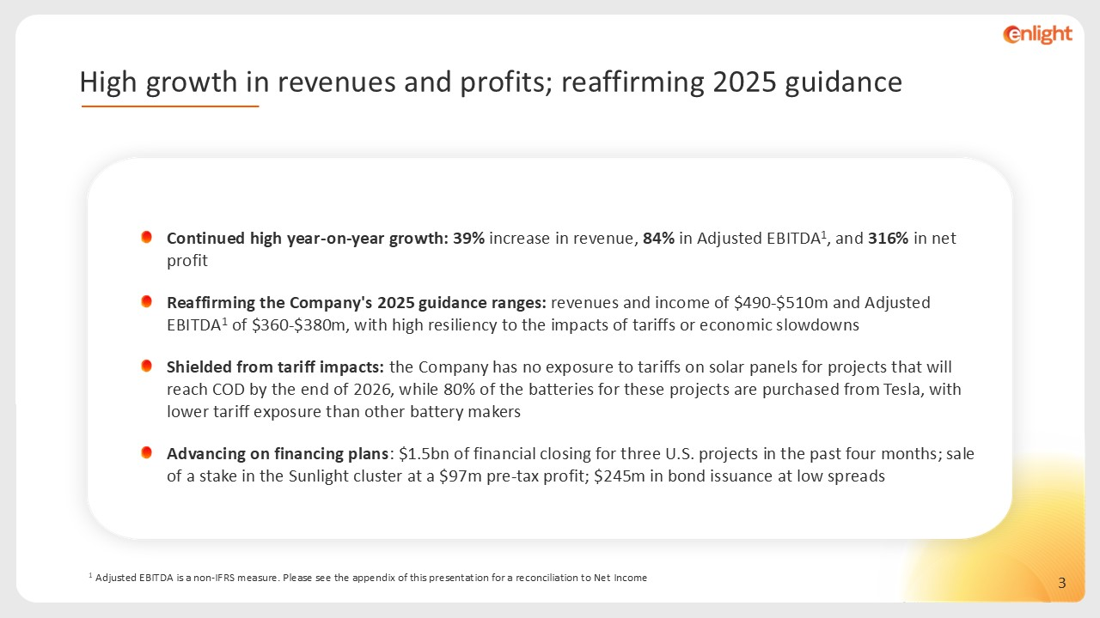
1 Adjusted EBITDA is a non-IFRS measure. Please see the appendix of this presentation for a reconciliation to Net Income Continued high year-on-year growth: 39% increase in revenue, 84% in Adjusted EBITDA1, and 316% in net profit Reaffirming the Company's 2025 guidance ranges: revenues and income of $490-$510m and Adjusted EBITDA1 of $360-$380m, with high resiliency to the impacts of tariffs or economic slowdowns Shielded from tariff impacts: the Company has no exposure to tariffs on solar panels for projects that will reach COD by the end of 2026, while 80% of the batteries for these projects are purchased from Tesla, with lower tariff exposure than other battery makers Advancing on financing plans: $1.5bn of financial closing for three U.S. projects in the past four months; sale of a stake in the Sunlight cluster at a $97m pre-tax profit; $245m in bond issuance at low spreads High growth in revenues and profits; reaffirming 2025 guidance

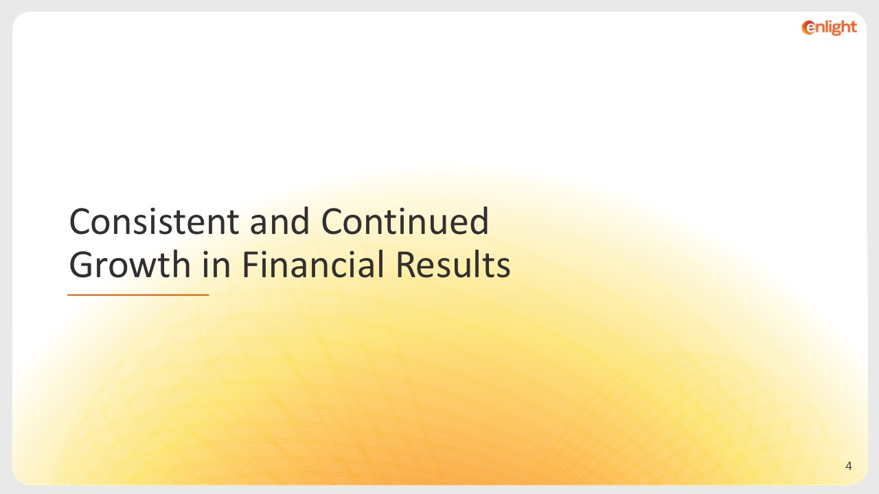
Consistent and Continued Growth in Financial Results

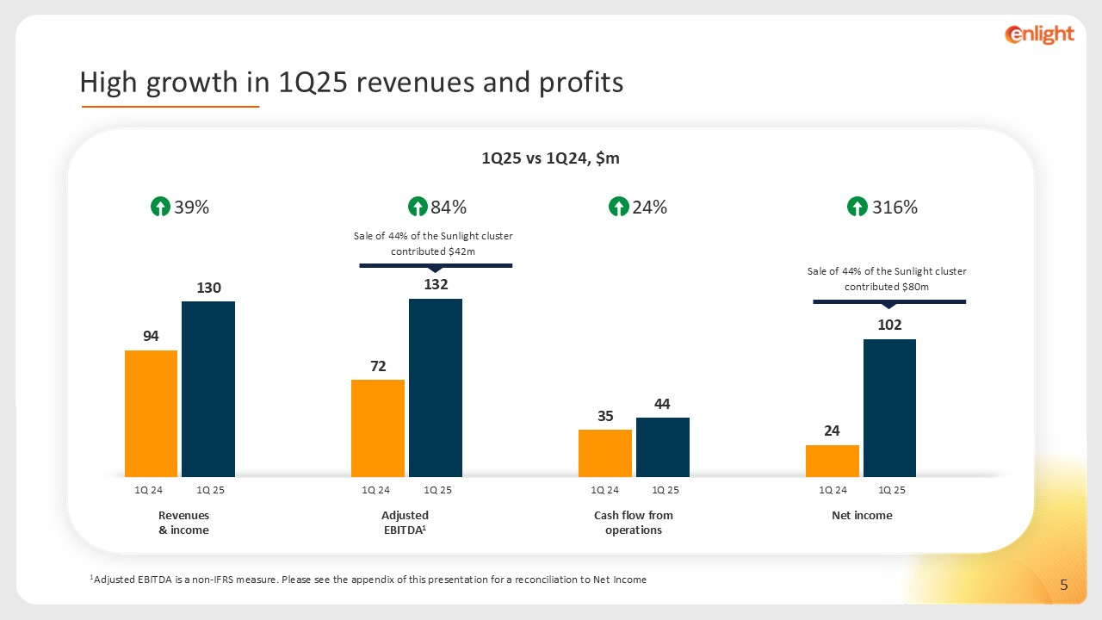
1Q25 vs 1Q24, $m 1Adjusted EBITDA is a non-IFRS measure. Please see the appendix of this presentation for a reconciliation to Net Income Revenues & income Adjusted EBITDA1 Cash flow from operations Net income 1Q 25 1Q 24 39% 84% 24% 316% Sale of 44% of the Sunlight cluster contributed $80m Sale of 44% of the Sunlight cluster contributed $42m 1Q 25 1Q 24 1Q 25 1Q 24 1Q 25 1Q 24 High growth in 1Q25 revenues and profits

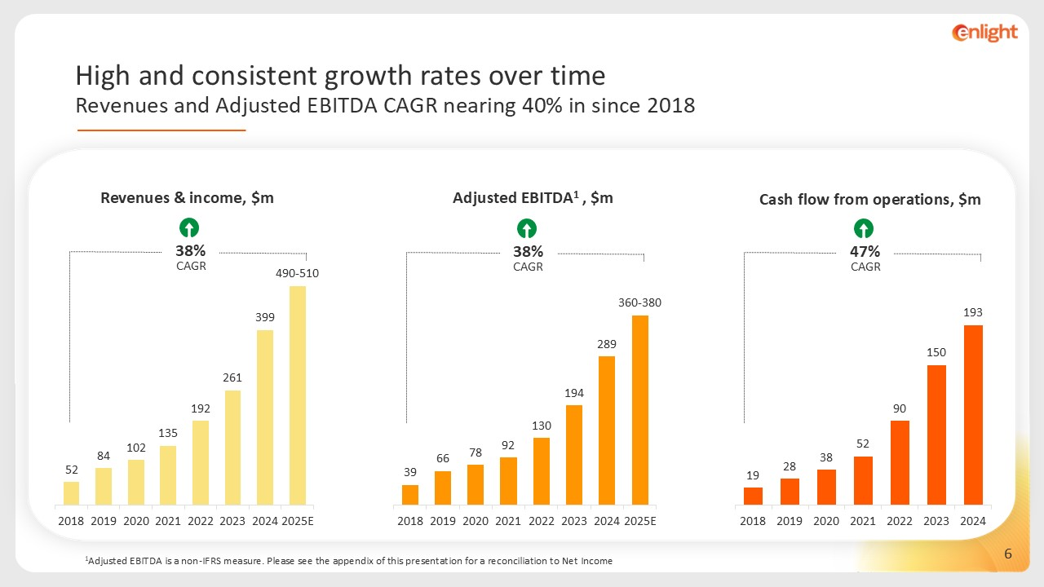
Revenues & income, $m 38% CAGR Adjusted EBITDA1 , $m 1Adjusted EBITDA is a non-IFRS measure. Please see the appendix of this presentation for a reconciliation to Net Income 38% CAGR 47% CAGR Cash flow from operations, $m High and consistent growth rates over time Revenues and Adjusted EBITDA CAGR nearing 40% in since 2018

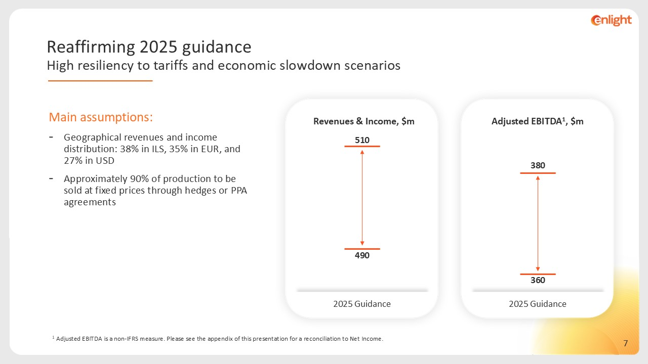
Main assumptions: Geographical revenues and income distribution: 38% in ILS, 35% in EUR, and 27% in USD Approximately 90% of production to be sold at fixed prices through hedges or PPA agreements 2025 Guidance Revenues & Income, $m 510 490 2025 Guidance Adjusted EBITDA1, $m 380 360 1 Adjusted EBITDA is a non-IFRS measure. Please see the appendix of this presentation for a reconciliation to Net Income. Reaffirming 2025 guidance High resiliency to tariffs and economic slowdown scenarios

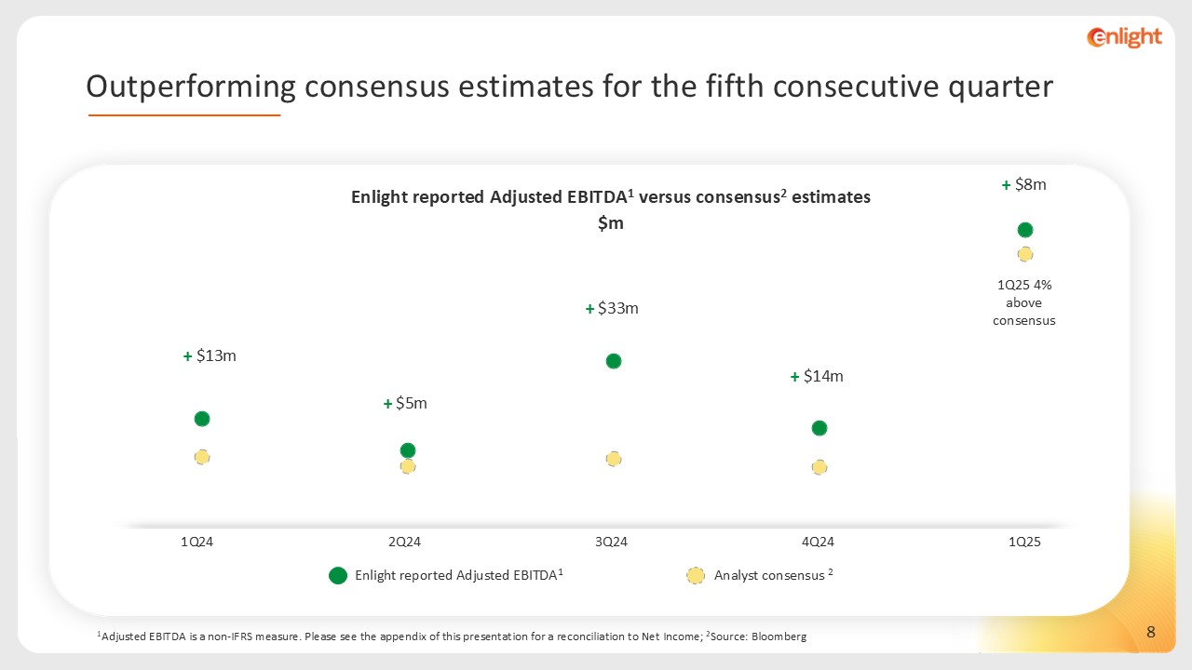
1Q25 4% above consensus Enlight reported Adjusted EBITDA1 Analyst consensus 2 Enlight reported Adjusted EBITDA1 versus consensus2 estimates $m 1Adjusted EBITDA is a non-IFRS measure. Please see the appendix of this presentation for a reconciliation to Net Income; 2Source: Bloomberg + $13m + $5m + $33m + $14m + $8m 2Q24 1Q24 3Q24 4Q24 1Q25 Outperforming consensus estimates for the fifth consecutive quarter

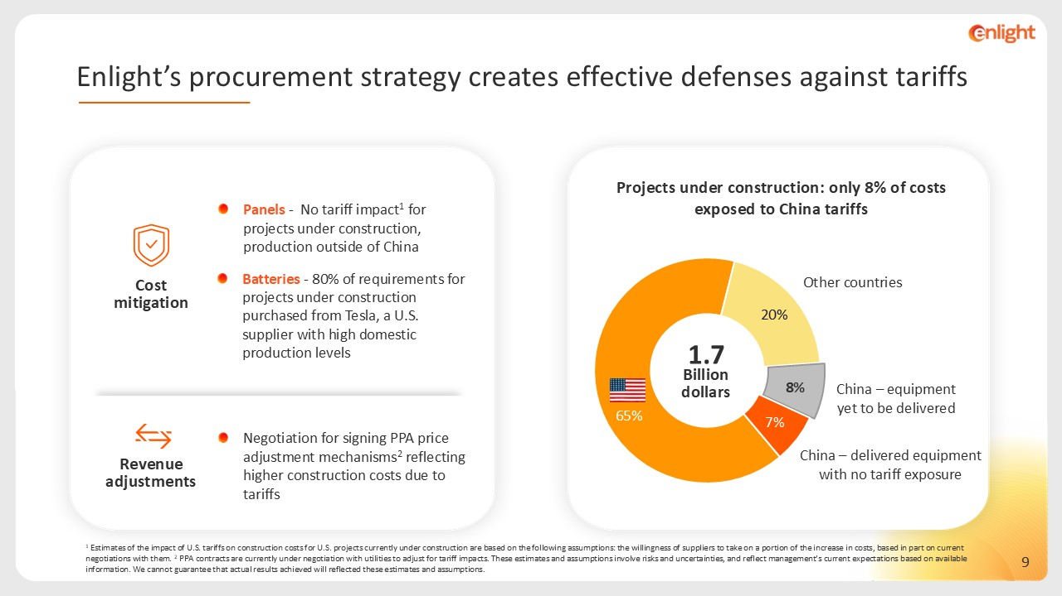
1 Estimates of the impact of U.S. tariffs on construction costs for U.S. projects currently under construction are based on the following assumptions: the willingness of suppliers to take on a portion of the increase in costs, based in part on current negotiations with them. 2 PPA contracts are currently under negotiation with utilities to adjust for tariff impacts. These estimates and assumptions involve risks and uncertainties, and reflect management’s current expectations based on available information. We cannot guarantee that actual results achieved will reflected these estimates and assumptions. Panels - No tariff impact1 for projects under construction, production outside of China Batteries - 80% of requirements for projects under construction purchased from Tesla, a U.S. supplier with high domestic production levels Cost mitigation Revenue adjustments Negotiation for signing PPA price adjustment mechanisms2 reflecting higher construction costs due to tariffs Other countries China – delivered equipment with no tariff exposure China – equipment yet to be delivered 1.7 Billion dollars Projects under construction: only 8% of costs exposed to China tariffs Enlight’s procurement strategy creates effective defenses against tariffs

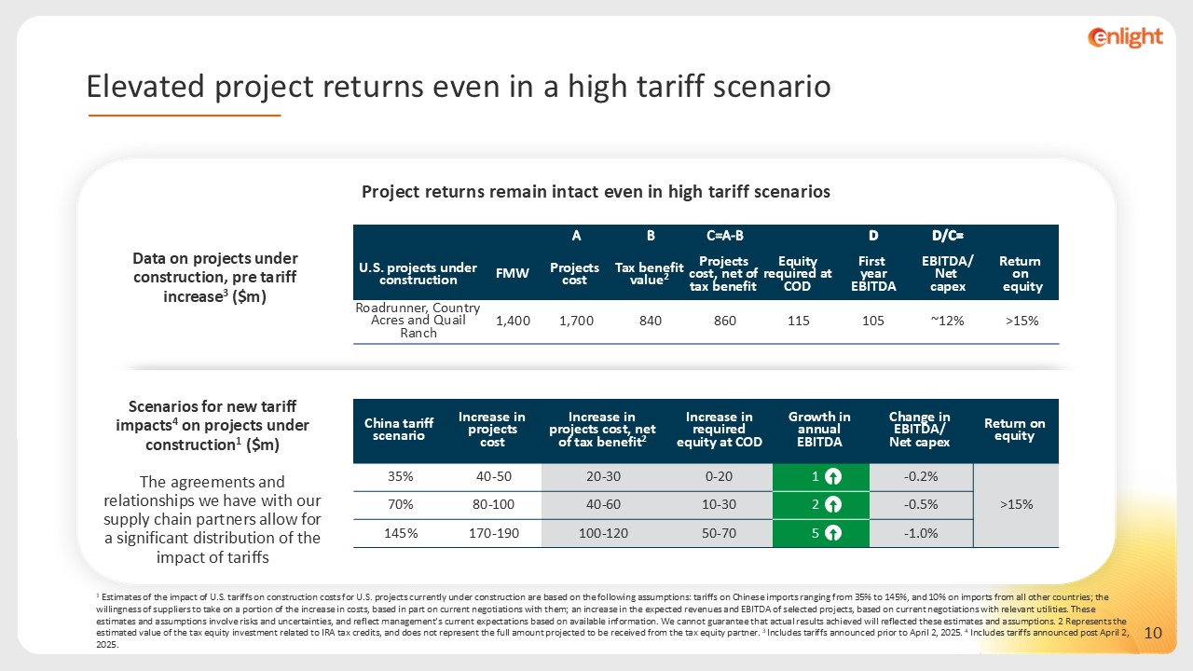
Project returns remain intact even in high tariff scenarios A B C=A-B D =D/C U.S. projects under construction FMW Projects cost Tax benefit value2 Projects cost, net of tax benefit Equity required at COD First year EBITDA EBITDA/ Net capex Return on equity Roadrunner, Country Acres and Quail Ranch 1,400 1,700 840 860 115 105 ~12% >15% China tariff scenario Increase in projects cost Increase in projects cost, net of tax benefit2 Increase in required equity at COD Growth in annual EBITDA Change in EBITDA/ Net capex Return on equity 35% 40-50 20-30 0-20 1 -0.2% >15% 70% 80-100 40-60 10-30 2 -0.5% 145% 170-190 100-120 50-70 5 -1.0% Data on projects under construction, pre tariff increase3 ($m) Scenarios for new tariff impacts4 on projects under construction1 ($m) The agreements and relationships we have with our supply chain partners allow for a significant distribution of the impact of tariffs 1 Estimates of the impact of U.S. tariffs on construction costs for U.S. projects currently under construction are based on the following assumptions: tariffs on Chinese imports ranging from 35% to 145%, and 10% on imports from all other countries; the willingness of suppliers to take on a portion of the increase in costs, based in part on current negotiations with them; an increase in the expected revenues and EBITDA of selected projects, based on current negotiations with relevant utilities. These estimates and assumptions involve risks and uncertainties, and reflect management’s current expectations based on available information. We cannot guarantee that actual results achieved will reflected these estimates and assumptions. 2 Represents the estimated value of the tax equity investment related to IRA tax credits, and does not represent the full amount projected to be received from the tax equity partner. 3 Includes tariffs announced prior to April 2, 2025. 4 Includes tariffs announced post April 2, 2025. Elevated project returns even in a high tariff scenario

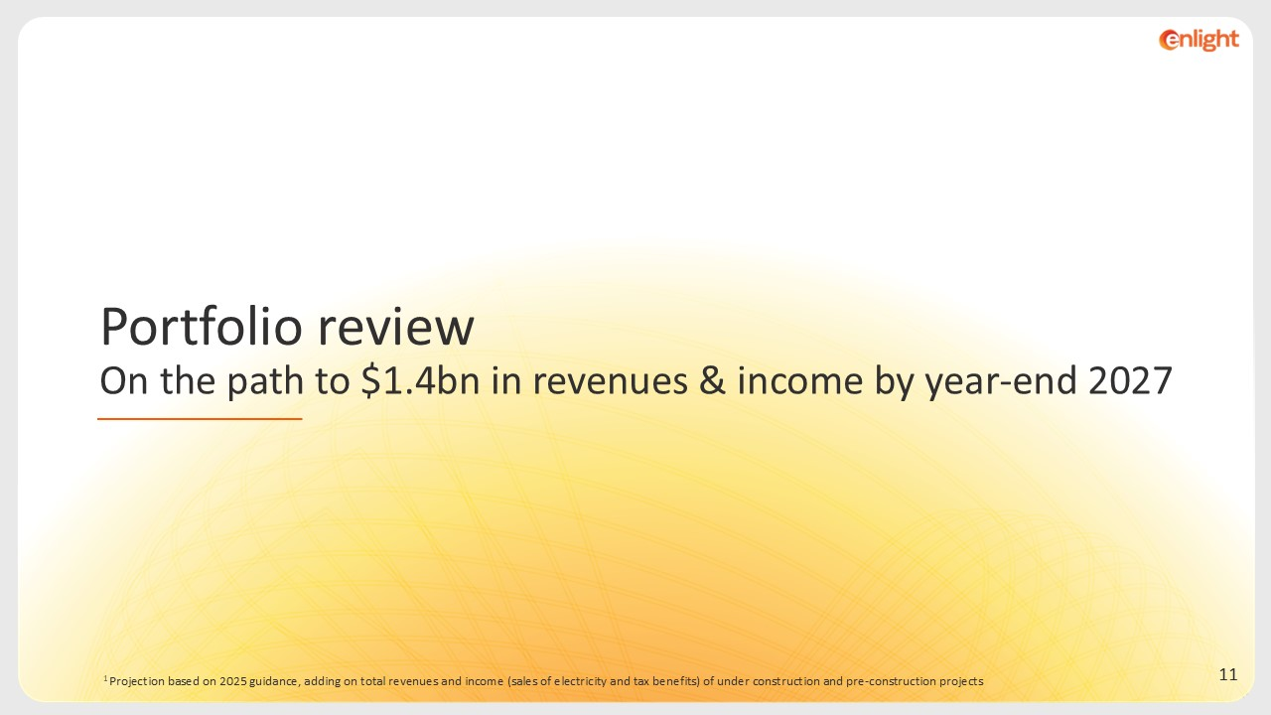
Portfolio review On the path to $1.4bn in revenues & income by year-end 2027 1 Projection based on 2025 guidance, adding on total revenues and income (sales of electricity and tax benefits) of under construction and pre-construction projects

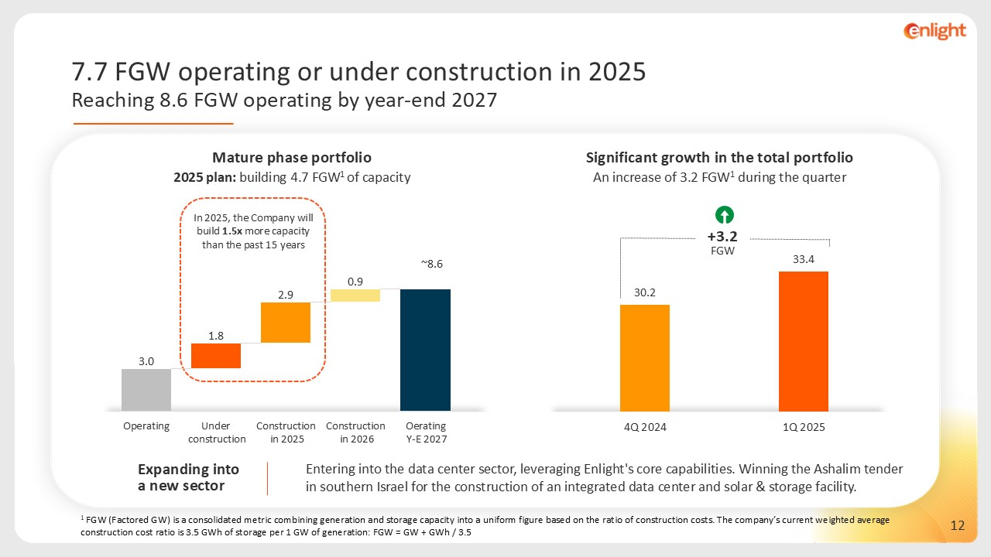
1 FGW (Factored GW) is a consolidated metric combining generation and storage capacity into a uniform figure based on the ratio of construction costs. The company’s current weighted average construction cost ratio is 3.5 GWh of storage per 1 GW of generation: FGW = GW + GWh / 3.5 2025 plan: building 4.7 FGW1 of capacity Entering into the data center sector, leveraging Enlight's core capabilities. Winning the Ashalim tender in southern Israel for the construction of an integrated data center and solar & storage facility. Significant growth in the total portfolio An increase of 3.2 FGW1 during the quarter ~8.6 Mature phase portfolio In 2025, the Company will build 1.5x more capacity than the past 15 years Expanding into a new sector +3.2 FGW 7.7 FGW operating or under construction in 2025 Reaching 8.6 FGW operating by year-end 2027

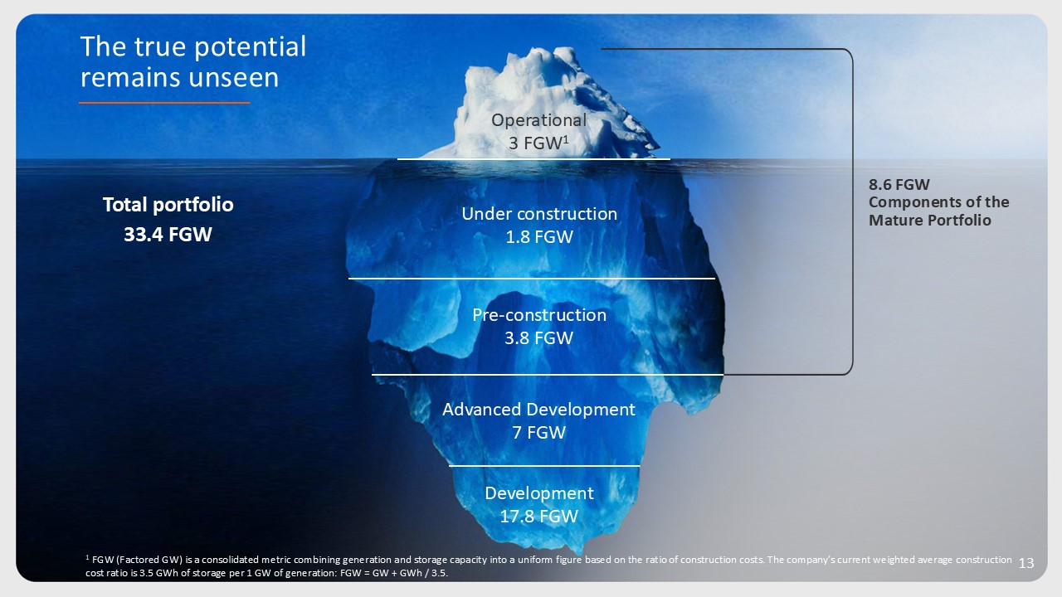
8.6 FGW Components of the Mature Portfolio Under construction FGW 1.8 Pre-construction FGW 3.8 Advanced Development FGW 7 Development FGW 17.8 Operational FGW1 3 1 FGW (Factored GW) is a consolidated metric combining generation and storage capacity into a uniform figure based on the ratio of construction costs. The company’s current weighted average construction cost ratio is 3.5 GWh of storage per 1 GW of generation: FGW = GW + GWh / 3.5. Total portfolio 33.4 FGW The true potential remains unseen

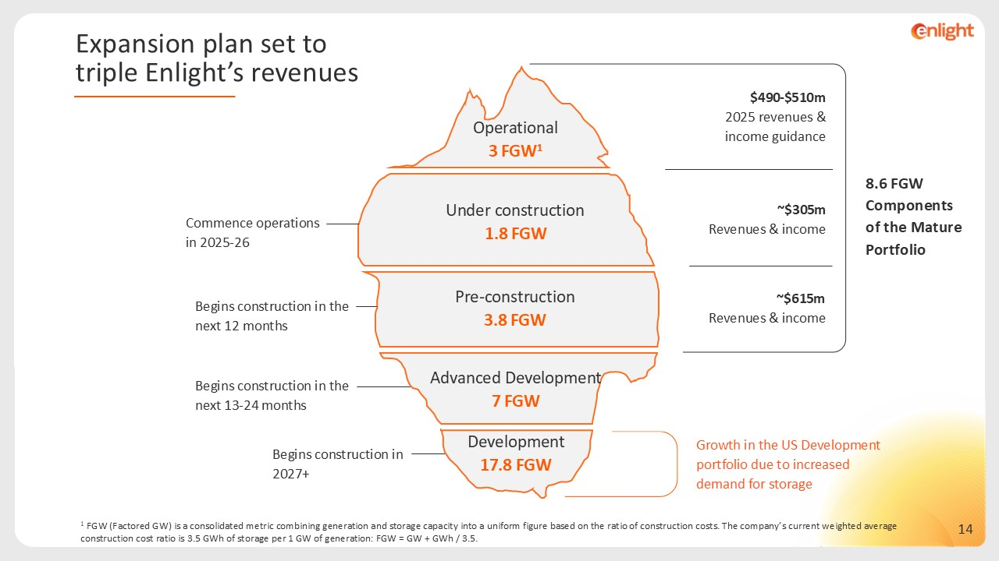
1 FGW (Factored GW) is a consolidated metric combining generation and storage capacity into a uniform figure based on the ratio of construction costs. The company’s current weighted average construction cost ratio is 3.5 GWh of storage per 1 GW of generation: FGW = GW + GWh / 3.5. Expansion plan set to triple Enlight’s revenues Commence operations in 2025-26 Begins construction in the next 12 months Begins construction in the next 13-24 months Begins construction in 2027+ Under construction FGW 1.8 Pre-construction FGW 3.8 Advanced Development FGW 7 Development FGW 17.8 Operational FGW1 3 8.6 FGW Components of the Mature Portfolio $490-$510m 2025 revenues & income guidance ~$305m Revenues & income ~$615m Revenues & income Growth in the US Development portfolio due to increased demand for storage

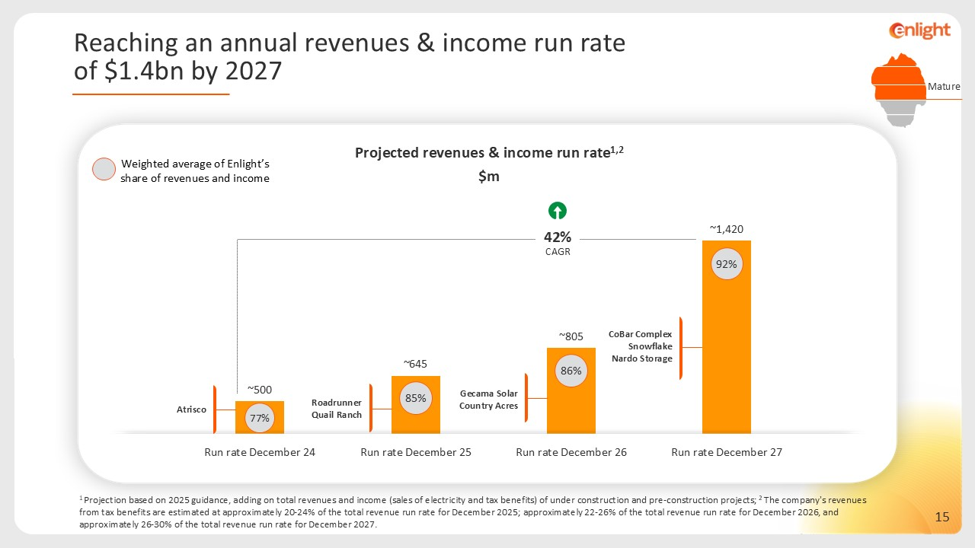
1 Projection based on 2025 guidance, adding on total revenues and income (sales of electricity and tax benefits) of under construction and pre-construction projects; 2 The company's revenues from tax benefits are estimated at approximately 20-24% of the total revenue run rate for December 2025; approximately 22-26% of the total revenue run rate for December 2026, and approximately 26-30% of the total revenue run rate for December 2027. CoBar Complex Snowflake Nardo Storage Roadrunner Quail Ranch Gecama Solar Country Acres 85% 86% 92% Projected revenues & income run rate1,2 $m Atrisco 77% Weighted average of Enlight’s share of revenues and income Mature Reaching an annual revenues & income run rate of $1.4bn by 2027 42% CAGR

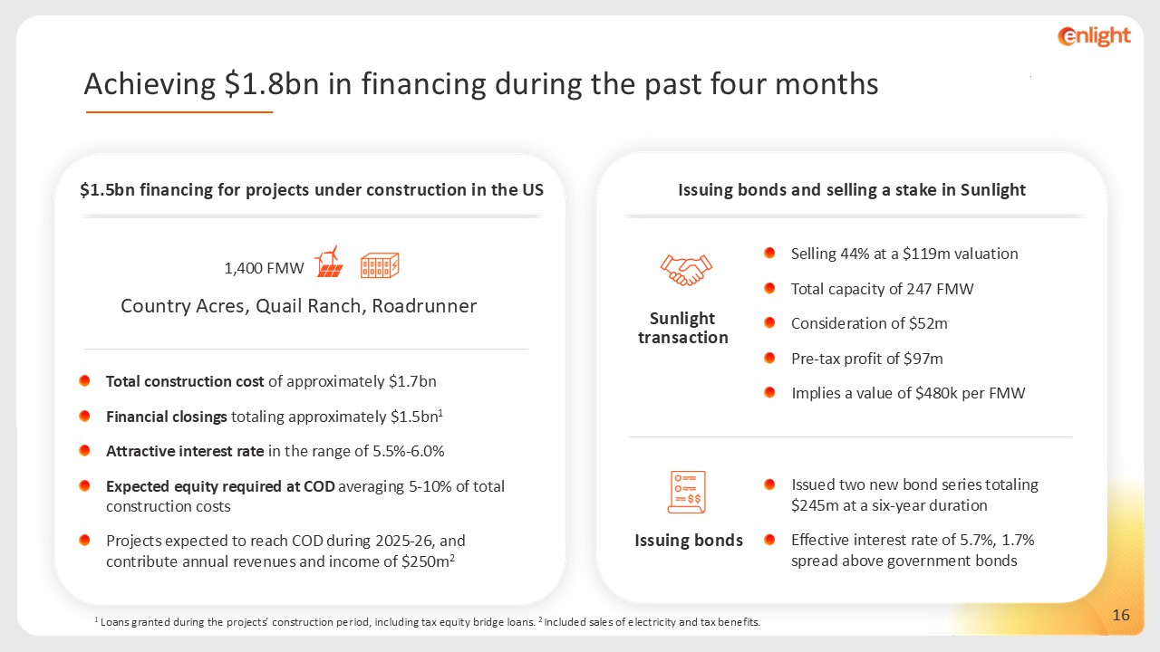
1 Loans granted during the projects’ construction period, including tax equity bridge loans. 2 Included sales of electricity and tax benefits. $1.5bn financing for projects under construction in the US 1,400 FMW Country Acres, Quail Ranch, Roadrunner Total construction cost of approximately $1.7bn Financial closings totaling approximately $1.5bn1 Attractive interest rate in the range of 5.5%-6.0% Expected equity required at COD averaging 5-10% of total construction costs Projects expected to reach COD during 2025-26, and contribute annual revenues and income of $250m2 Issuing bonds and selling a stake in Sunlight Sunlight transaction Selling 44% at a $119m valuation Total capacity of 247 FMW Consideration of $52m Pre-tax profit of $97m Implies a value of $480k per FMW Issued two new bond series totaling $245m at a six-year duration Effective interest rate of 5.7%, 1.7% spread above government bonds Issuing bonds Achieving $1.8bn in financing during the past four months

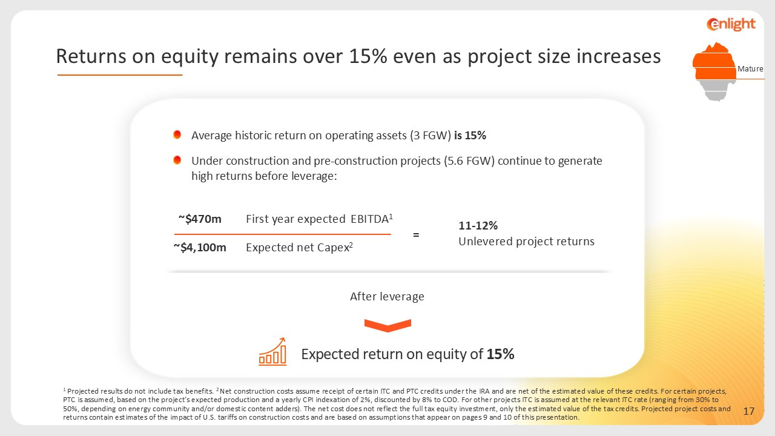
Average historic return on operating assets (3 FGW) is 15% Under construction and pre-construction projects (5.6 FGW) continue to generate high returns before leverage: 11-12% Unlevered project returns EBITDA1 First year expected ~$470m Expected net Capex2 ~$4,100m = Expected return on equity of 15% After leverage 1 Projected results do not include tax benefits. 2 Net construction costs assume receipt of certain ITC and PTC credits under the IRA and are net of the estimated value of these credits. For certain projects, PTC is assumed, based on the project’s expected production and a yearly CPI indexation of 2%, discounted by 8% to COD. For other projects ITC is assumed at the relevant ITC rate (ranging from 30% to 50%, depending on energy community and/or domestic content adders). The net cost does not reflect the full tax equity investment, only the estimated value of the tax credits. Projected project costs and returns contain estimates of the impact of U.S. tariffs on construction costs and are based on assumptions that appear on pages 9 and 10 of this presentation. Mature Returns on equity remains over 15% even as project size increases

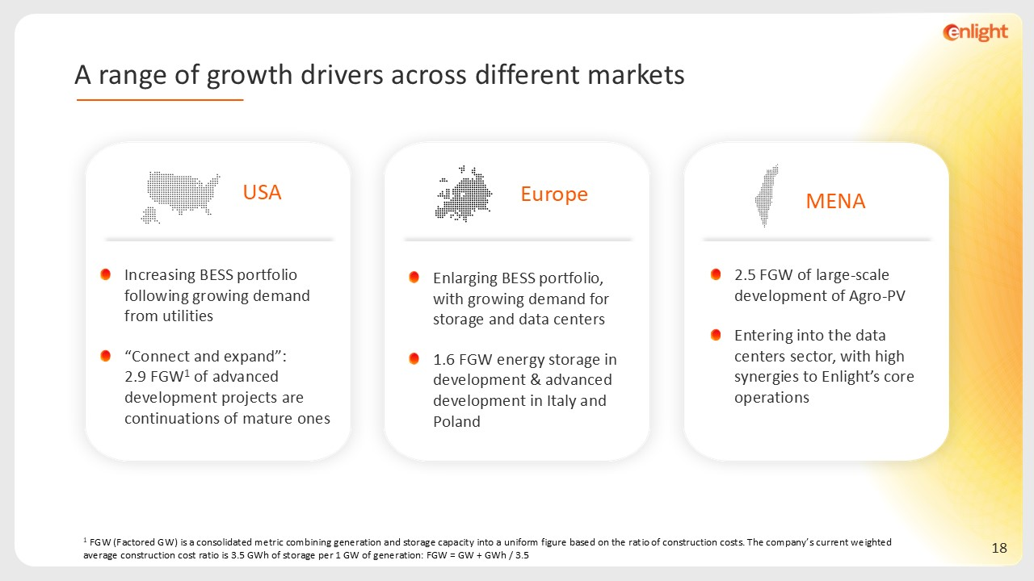
MENA 2.5 FGW of large-scale development of Agro-PV Entering into the data centers sector, with high synergies to Enlight’s core operations 1 FGW (Factored GW) is a consolidated metric combining generation and storage capacity into a uniform figure based on the ratio of construction costs. The company’s current weighted average construction cost ratio is 3.5 GWh of storage per 1 GW of generation: FGW = GW + GWh / 3.5 Europe Enlarging BESS portfolio, with growing demand for storage and data centers 1.6 FGW energy storage in development & advanced development in Italy and Poland USA Increasing BESS portfolio following growing demand from utilities “Connect and expand”: 2.9 FGW1 of advanced development projects are continuations of mature ones A range of growth drivers across different markets

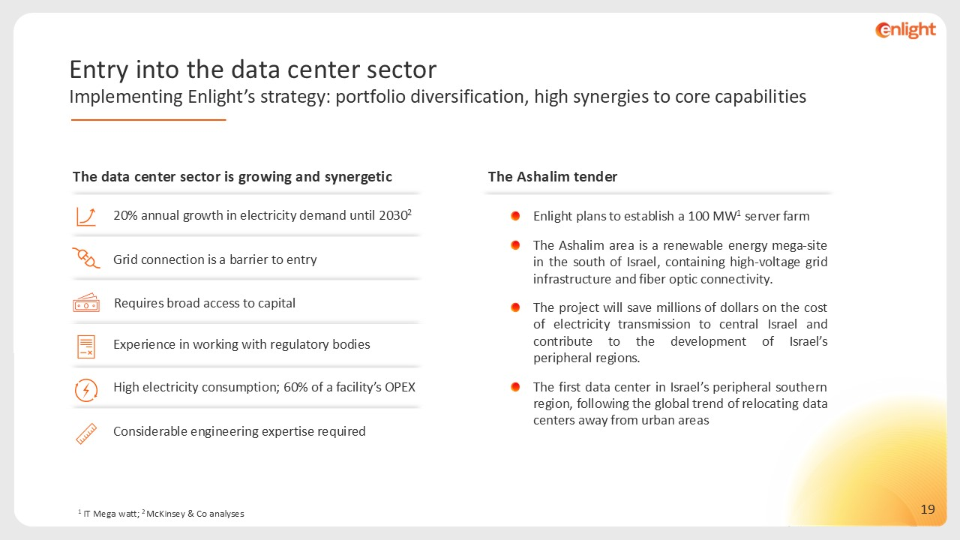
1 IT Mega watt; 2 McKinsey & Co analyses The Ashalim tender Enlight plans to establish a 100 MW1 server farm The Ashalim area is a renewable energy mega-site in the south of Israel, containing high-voltage grid infrastructure and fiber optic connectivity. The project will save millions of dollars on the cost of electricity transmission to central Israel and contribute to the development of Israel’s peripheral regions. The first data center in Israel’s peripheral southern region, following the global trend of relocating data centers away from urban areas The data center sector is growing and synergetic Requires broad access to capital Experience in working with regulatory bodies High electricity consumption; 60% of a facility’s OPEX Grid connection is a barrier to entry Considerable engineering expertise required 20% annual growth in electricity demand until 20302 Entry into the data center sector Implementing Enlight’s strategy: portfolio diversification, high synergies to core capabilities

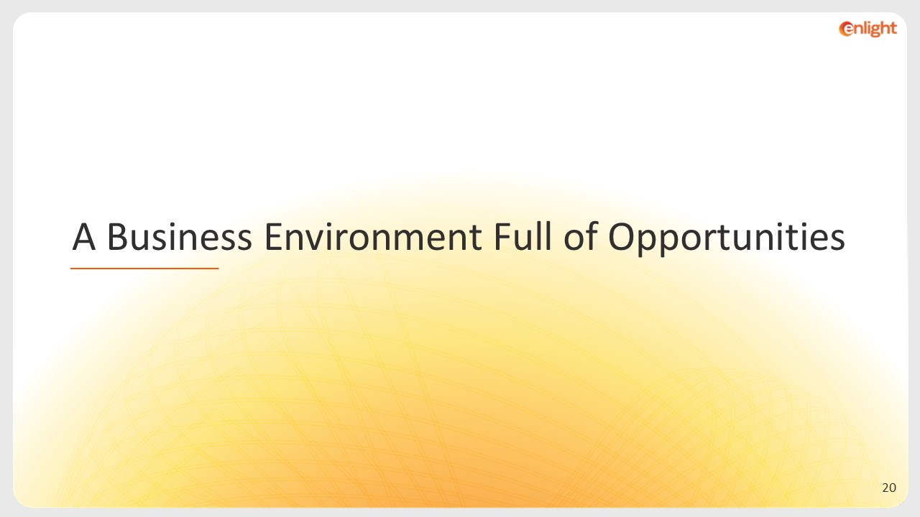
A Business Environment Full of Opportunities

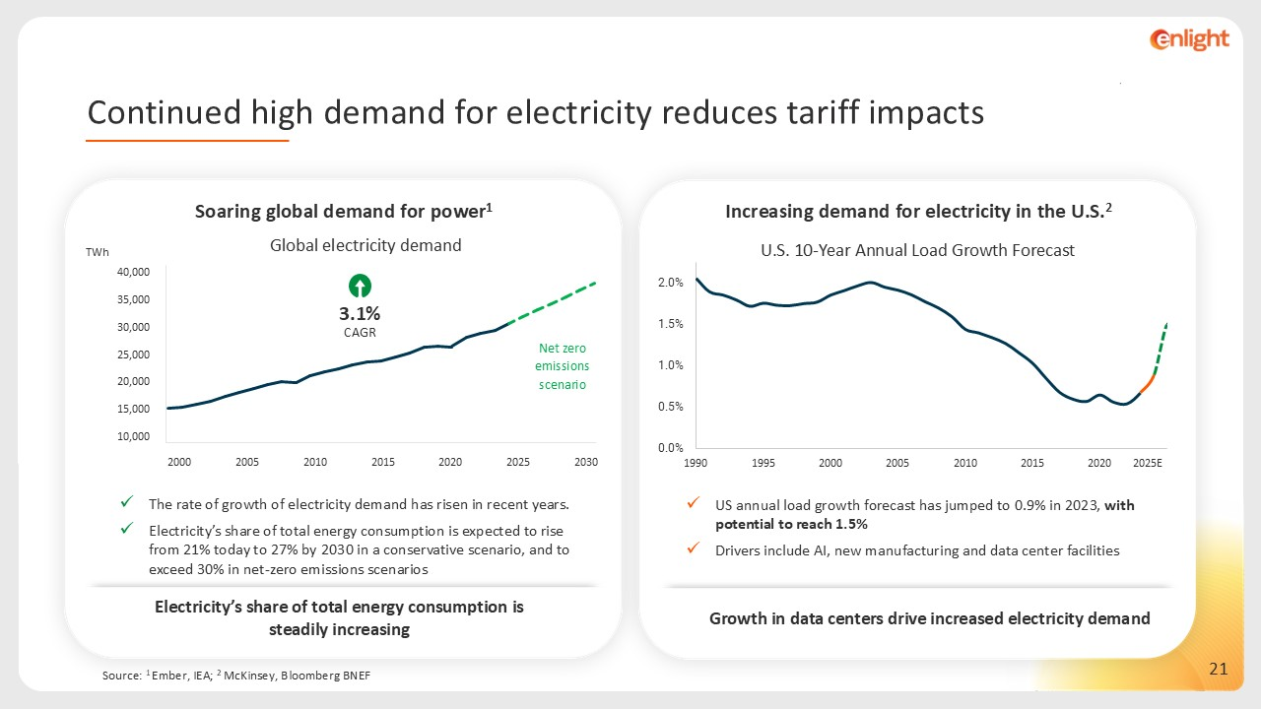
Source: 1 Ember, IEA; 2 McKinsey, Bloomberg BNEF Increasing demand for electricity in the U.S.2 2025E US annual load growth forecast has jumped to 0.9% in 2023, with potential to reach 1.5% Drivers include AI, new manufacturing and data center facilities Electricity’s share of total energy consumption is steadily increasing Soaring global demand for power1 The rate of growth of electricity demand has risen in recent years. Electricity’s share of total energy consumption is expected to rise from 21% today to 27% by 2030 in a conservative scenario, and to exceed 30% in net-zero emissions scenarios TWh Net zero emissions scenario 3.1% CAGR 2000 2010 2020 2030 2005 2015 2025 Growth in data centers drive increased electricity demand Continued high demand for electricity reduces tariff impacts

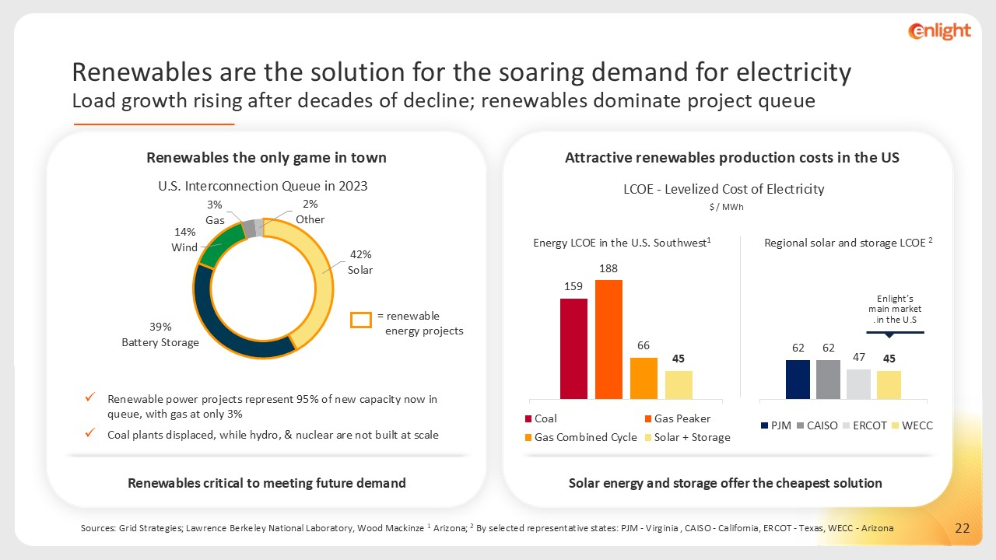
Renewables critical to meeting future demand Renewables the only game in town Renewable power projects represent 95% of new capacity now in queue, with gas at only 3% Coal plants displaced, while hydro, & nuclear are not built at scale = renewable energy projects Sources: Grid Strategies; Lawrence Berkeley National Laboratory, Wood Mackinze 1 Arizona; 2 By selected representative states: PJM - Virginia , CAISO - California, ERCOT - Texas, WECC - Arizona Solar energy and storage offer the cheapest solution LCOE - Levelized Cost of Electricity Attractive renewables production costs in the US $ / MWh 1Energy LCOE in the U.S. Southwest 2 Regional solar and storage LCOE Enlight’s main market in the U.S. Renewables are the solution for the soaring demand for electricity Load growth rising after decades of decline; renewables dominate project queue




Appendix

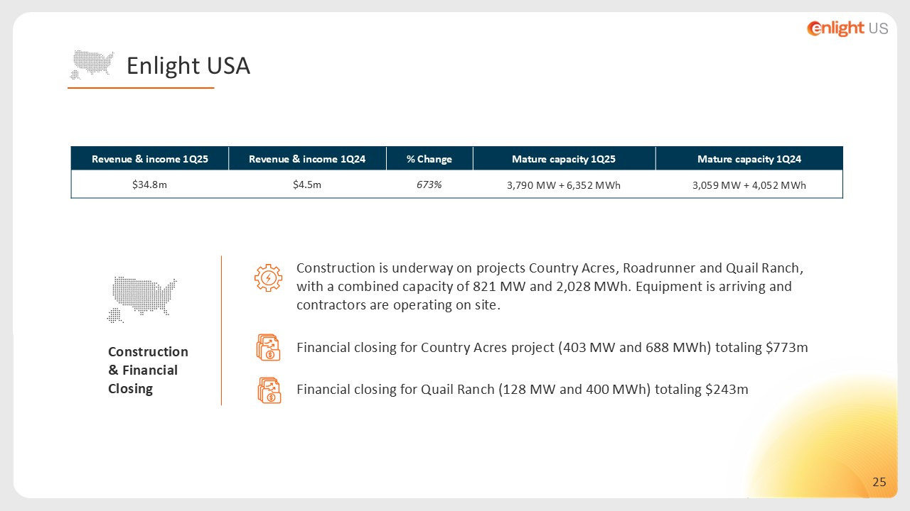
Construction is underway on projects Country Acres, Roadrunner and Quail Ranch, with a combined capacity of 821 MW and 2,028 MWh. Equipment is arriving and contractors are operating on site. Financial closing for Country Acres project (403 MW and 688 MWh) totaling $773m Financial closing for Quail Ranch (128 MW and 400 MWh) totaling $243m Construction & Financial Closing Revenue & income 1Q25 Revenue & income 1Q24 % Change Mature capacity 1Q25 Mature capacity 1Q24 $34.8m $4.5m 673% 3,790 MW + 6,352 MWh 3,059 MW + 4,052 MWh Enlight USA

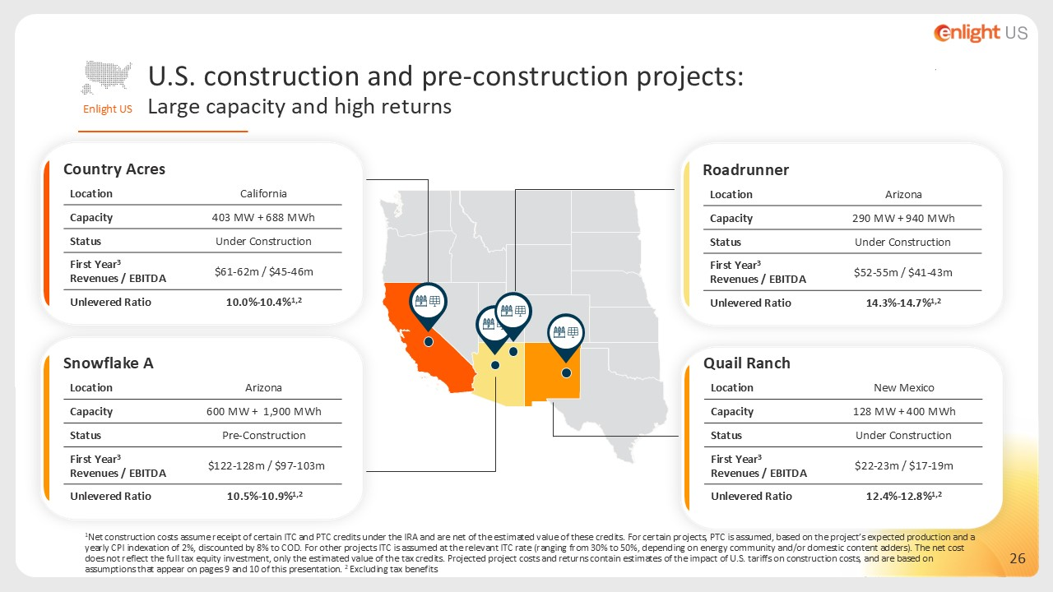
New Mexico Location 128 MW + 400 MWh Capacity Under Construction Status $22-23m / $17-19m First Year3Revenues / EBITDA 12.4%-12.8%1,2 Unlevered Ratio Quail Ranch Snowflake A California Location 403 MW + 688 MWh Capacity Under Construction Status $61-62m / $45-46m First Year3Revenues / EBITDA 10.0%-10.4%1,2 Unlevered Ratio Country Acres Arizona Location 290 MW + 940 MWh Capacity Under Construction Status $52-55m / $41-43m First Year3 Revenues / EBITDA 14.3%-14.7%1,2 Unlevered Ratio Roadrunner Arizona Location 600 MW + 1,900 MWh Capacity Pre-Construction Status $122-128m / $97-103m First Year3 Revenues / EBITDA 10.5%-10.9%1,2 Unlevered Ratio 1Net construction costs assume receipt of certain ITC and PTC credits under the IRA and are net of the estimated value of these credits. For certain projects, PTC is assumed, based on the project’s expected production and a yearly CPI indexation of 2%, discounted by 8% to COD. For other projects ITC is assumed at the relevant ITC rate (ranging from 30% to 50%, depending on energy community and/or domestic content adders). The net cost does not reflect the full tax equity investment, only the estimated value of the tax credits. Projected project costs and returns contain estimates of the impact of U.S. tariffs on construction costs, and are based on assumptions that appear on pages 9 and 10 of this presentation. 2 Excluding tax benefits Enlight US U.S. construction and pre-construction projects: Large capacity and high returns

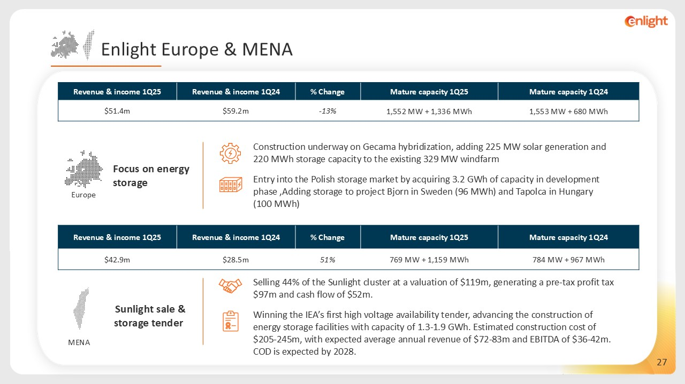
Construction underway on Gecama hybridization, adding 225 MW solar generation and 220 MWh storage capacity to the existing 329 MW windfarm Entry into the Polish storage market by acquiring 3.2 GWh of capacity in development phase ,Adding storage to project Bjorn in Sweden (96 MWh) and Tapolca in Hungary (100 MWh) Focus on energy storage Sunlight sale & storage tender Selling 44% of the Sunlight cluster at a valuation of $119m, generating a pre-tax profit tax $97m and cash flow of $52m. Winning the IEA’s first high voltage availability tender, advancing the construction of energy storage facilities with capacity of 1.3-1.9 GWh. Estimated construction cost of $205-245m, with expected average annual revenue of $72-83m and EBITDA of $36-42m. COD is expected by 2028. Revenue & income 1Q25 Revenue & income 1Q24 % Change Mature capacity 1Q25 Mature capacity 1Q24 $51.4m $59.2m -13% 1,552 MW + 1,336 MWh 1,553 MW + 680 MWh Revenue & income 1Q25 Revenue & income 1Q24 % Change Mature capacity 1Q25 Mature capacity 1Q24 $42.9m $28.5m 51% 769 MW + 1,159 MWh 784 MW + 967 MWh Europe MENA Enlight Europe & MENA

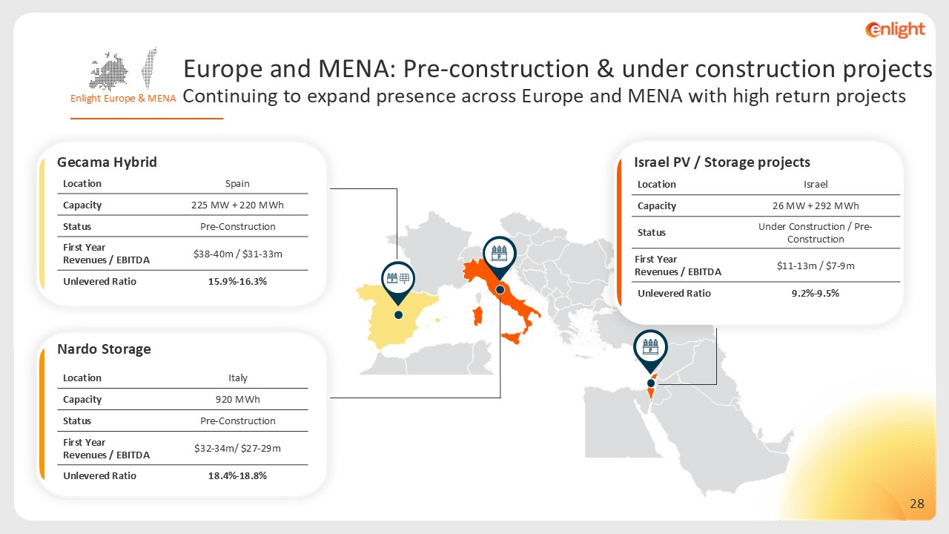
Israel Location 26 MW + 292 MWh Capacity Under Construction / Pre-Construction Status $11-13m / $7-9m First Year Revenues / EBITDA 9.2%-9.5% Unlevered Ratio Israel PV / Storage projects Nardo Storage Spain Location 225 MW + 220 MWh Capacity Pre-Construction Status $38-40m / $31-33m First Year Revenues / EBITDA 15.9%-16.3% Unlevered Ratio Gecama Hybrid Italy Location 920 MWh Capacity Pre-Construction Status $32-34m/ $27-29m First Year Revenues / EBITDA 18.4%-18.8% Unlevered Ratio Enlight Europe & MENA Europe and MENA: Pre-construction & under construction projects Continuing to expand presence across Europe and MENA with high return projects

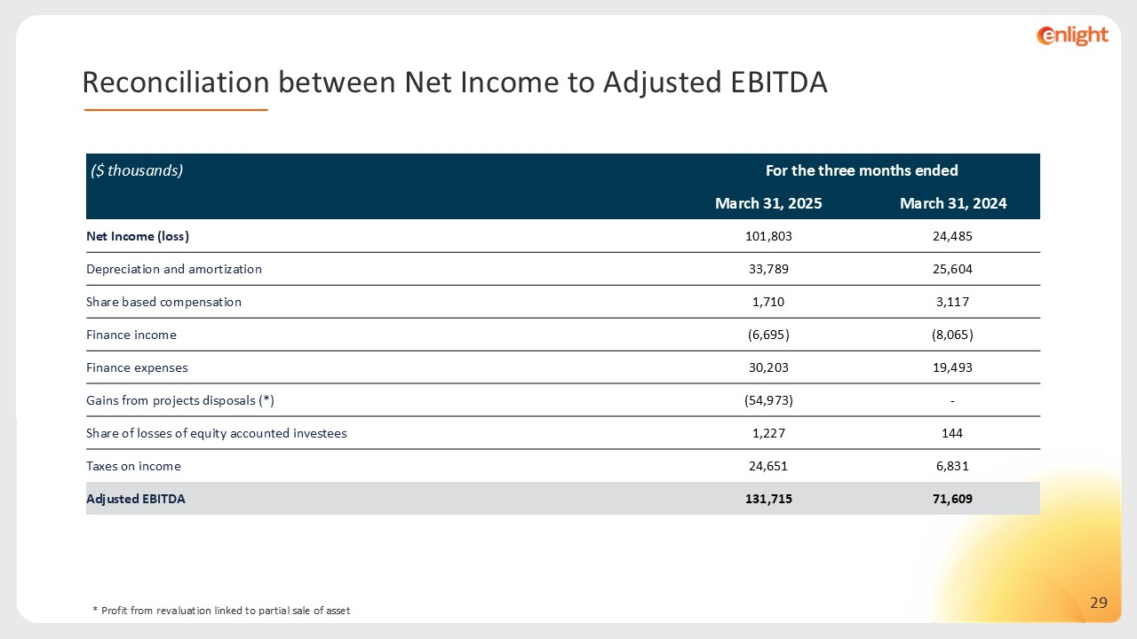
($ thousands) For the three months ended March 31, 2025 March 31, 2024 Net Income (loss) 101,803 24,485 Depreciation and amortization 33,789 25,604 Share based compensation 1,710 3,117 Finance income (6,695) (8,065) Finance expenses 30,203 19,493 Gains from projects disposals (*) (54,973) - Share of losses of equity accounted investees 1,227 144 Taxes on income 24,651 6,831 Adjusted EBITDA 131,715 71,609 * Profit from revaluation linked to partial sale of asset Reconciliation between Net Income to Adjusted EBITDA

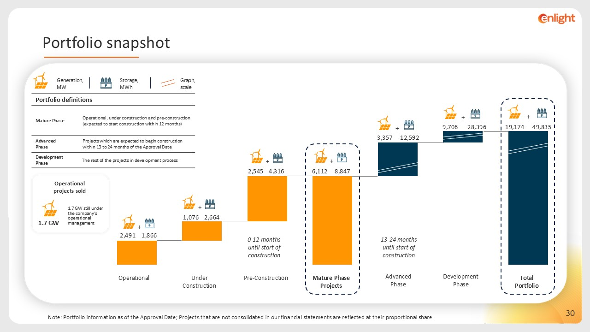
Graph, scale Generation, MW Storage, MWh Portfolio definitions Operational, under construction and pre-construction (expected to start construction within 12 months) Mature Phase Projects which are expected to begin construction within 13 to 24 months of the Approval Date Advanced Phase The rest of the projects in development process Development Phase Advanced Phase Under Construction Operational Pre-Construction Mature Phase Projects Development Phase Total Portfolio 0-12 months until start of construction 13-24 months until start of construction + + + + + + + Operational projects sold 1.7 GW still under the company’s operational management 1.7 GW 2,491 6,112 2,545 4,316 1,076 28,396 12,592 49,835 8,847 2,664 9,706 3,357 19,174 1,866 Portfolio snapshot Note: Portfolio information as of the Approval Date; Projects that are not consolidated in our financial statements are reflected at their proportional share

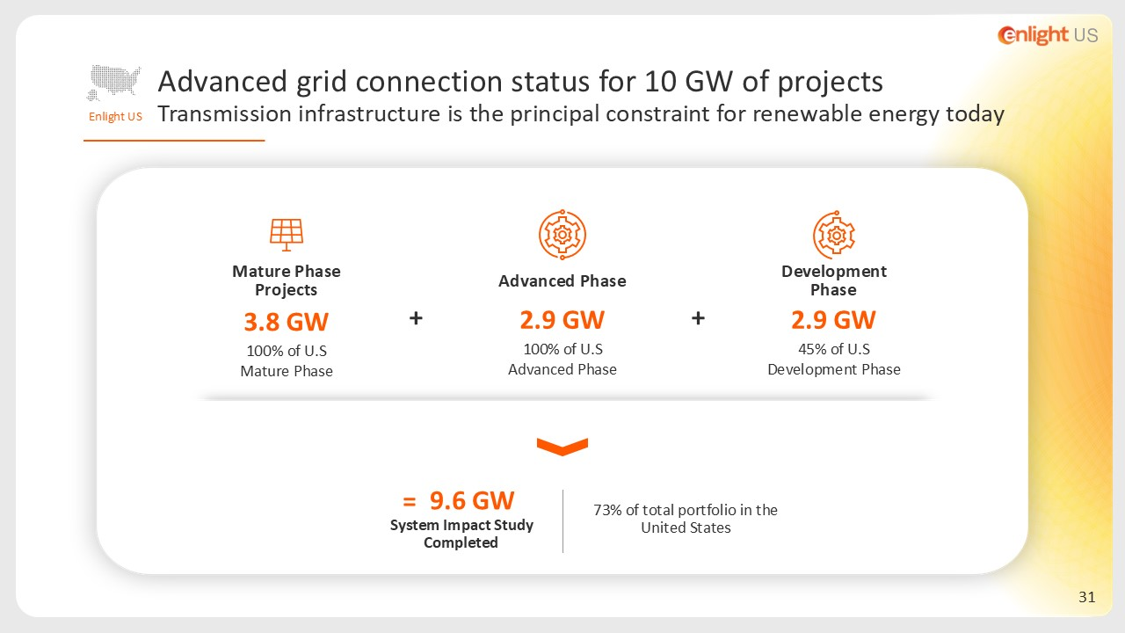
73% of total portfolio in the United States 2.9 GW 45% of U.S Development Phase Development Phase Advanced Phase 2.9 GW 100% of U.S Advanced Phase Mature Phase Projects 3.8 GW 100% of U.S Mature Phase 9.6 GW System Impact Study Completed + + = Enlight US Advanced grid connection status for 10 GW of projects Transmission infrastructure is the principal constraint for renewable energy today

